Login to the website and find your team page under TEAM CENTRAL – TEAM DIRECTORY
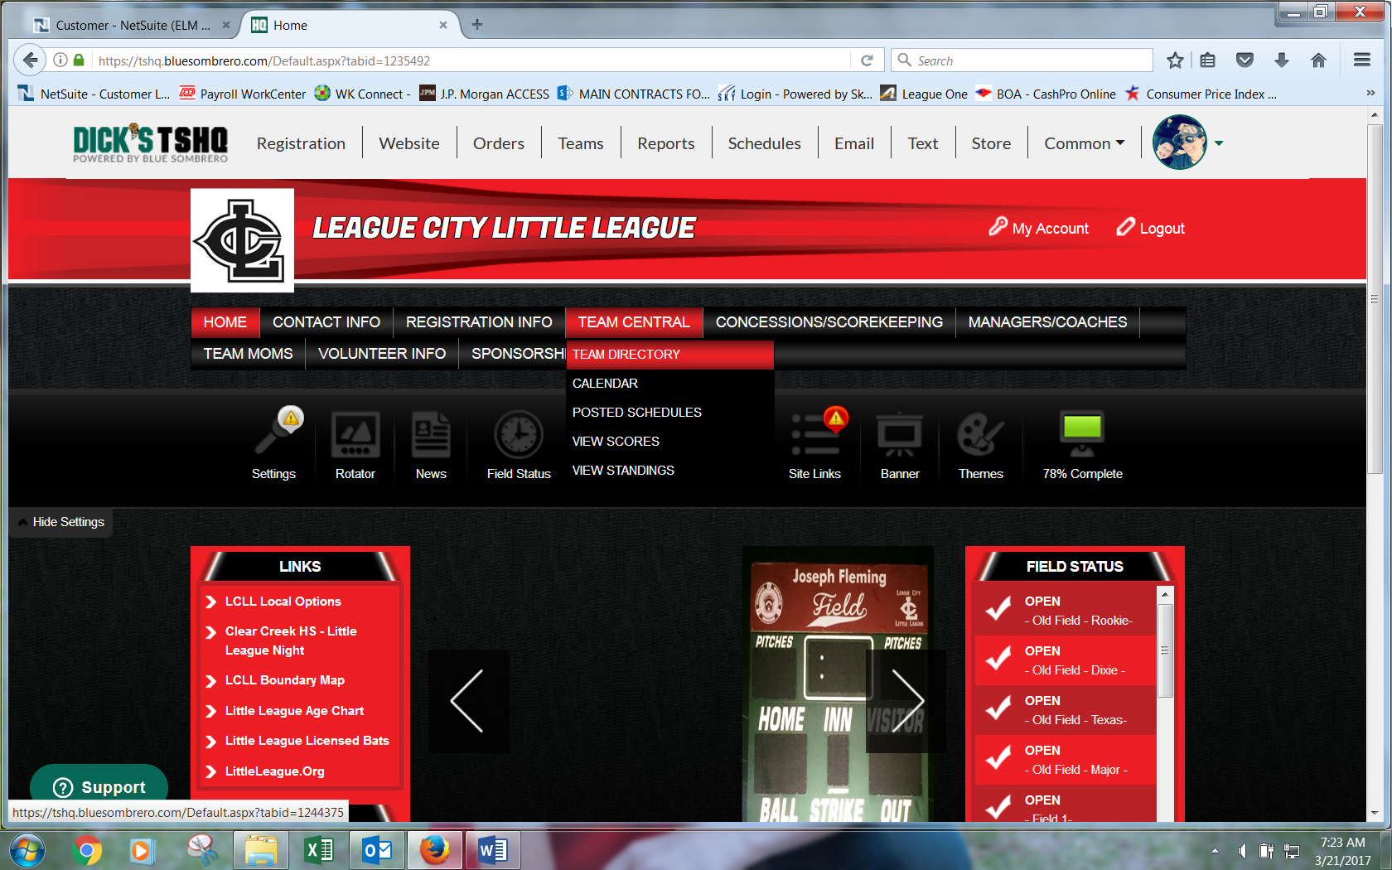
Once on TEAM DIRECTORY select the appropriate league (Amer or Natl) and division
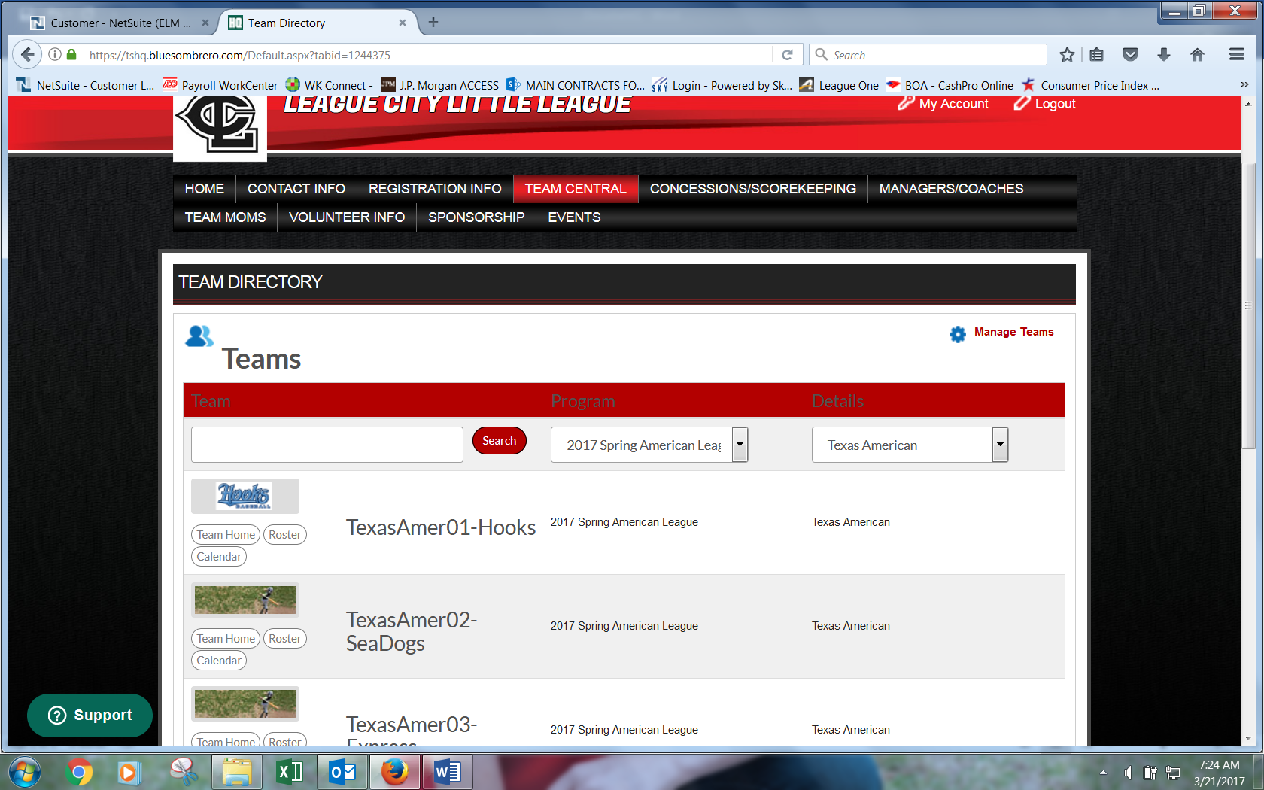

Once on the team page choose the CALENDAR tab and then the RESULTS option
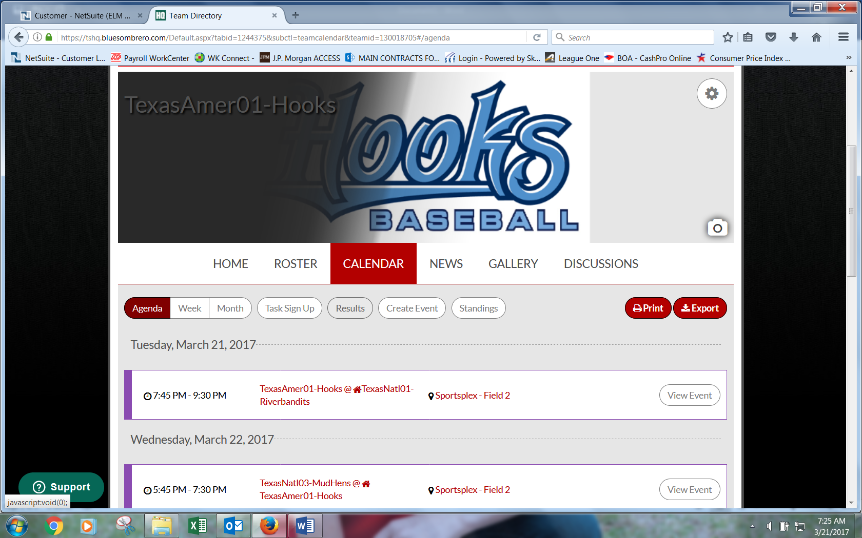
After you choose RESULTS you will see games and any that are home games will have the option to the right, EDIT SCORES
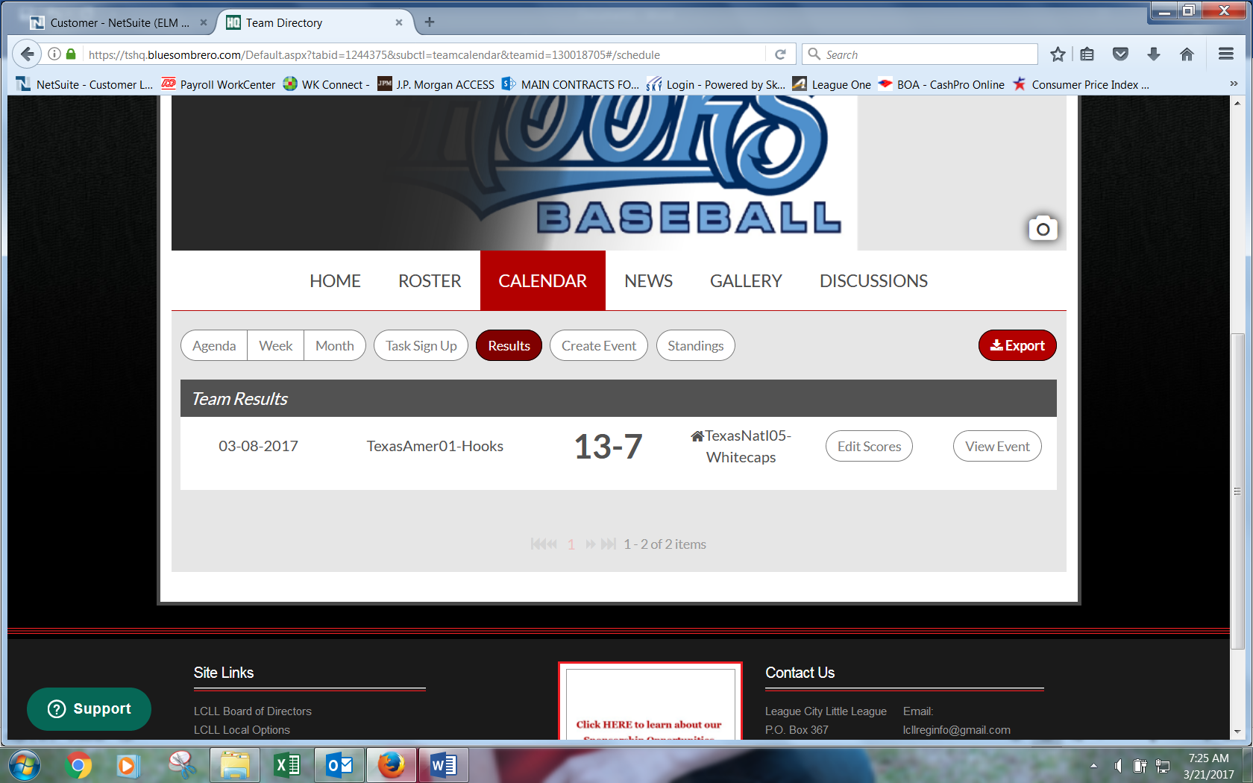

When entering the scores the visitor team will be first and the home team next.
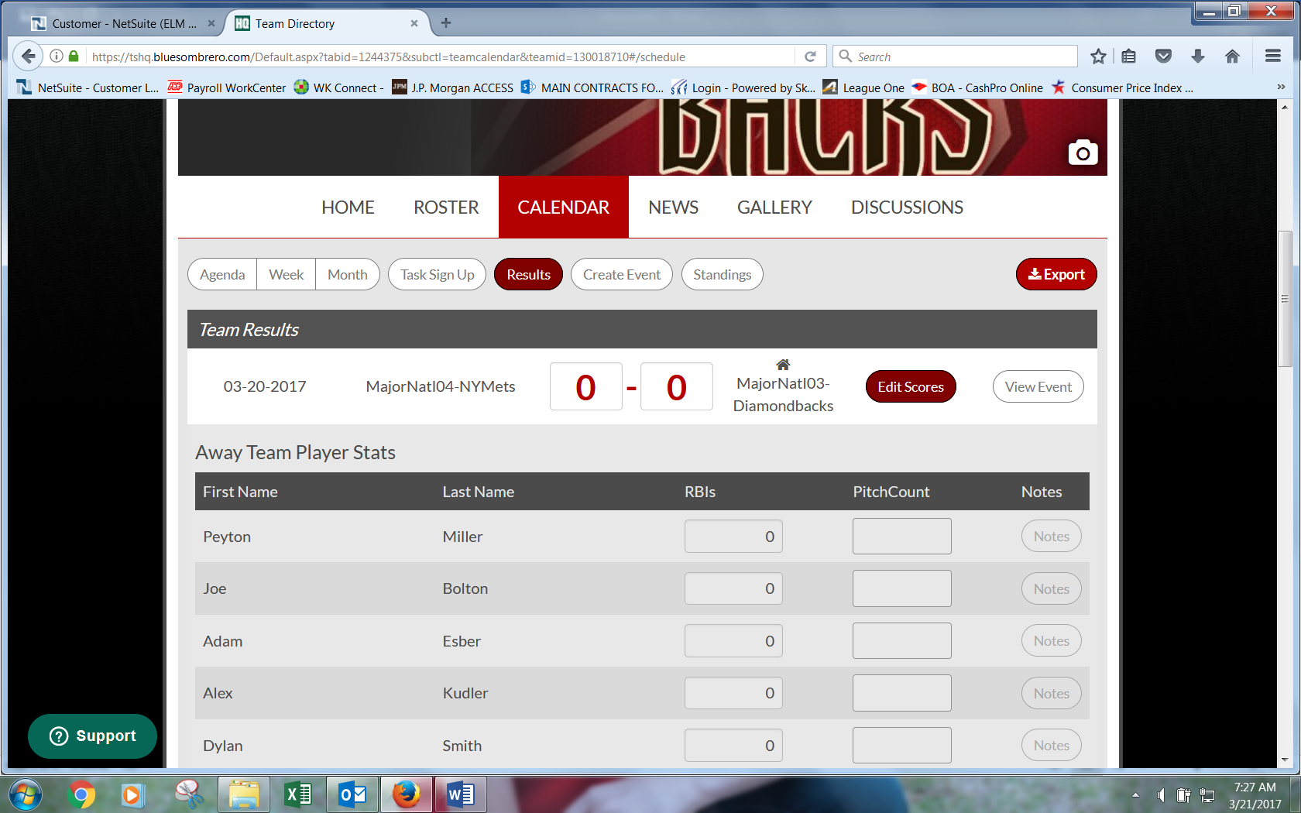
After you enter the scores, scroll to the bottom of the page (past the player stat entry – ignore) and click SAVE & POST
