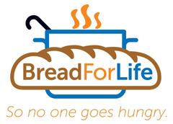

Southington South is running a food drive
April 22nd thru May 6th
to benefit Southington Bread for Life.
Please help us feed the Southington community.

Bread for life needs the following items:

T-Ball Teams | Snacks  (individual packs of pretzels, chips, granola bars)
Double-A Teams | Individual Cereal Packs  Coffee (ground)
Triple-A Teams | Pasta & Pasta Sauce  Salad Dressing
Majors Teams | Canned Goods & Instant Potatoes  (gravy, chili, soups, vegetables)

Bring your goods to your next practice or game and give to a coach
or donate directly at the Concession Stand.

Let’s show our children it pays to give back!

