Aurora Raptors Travel Softball
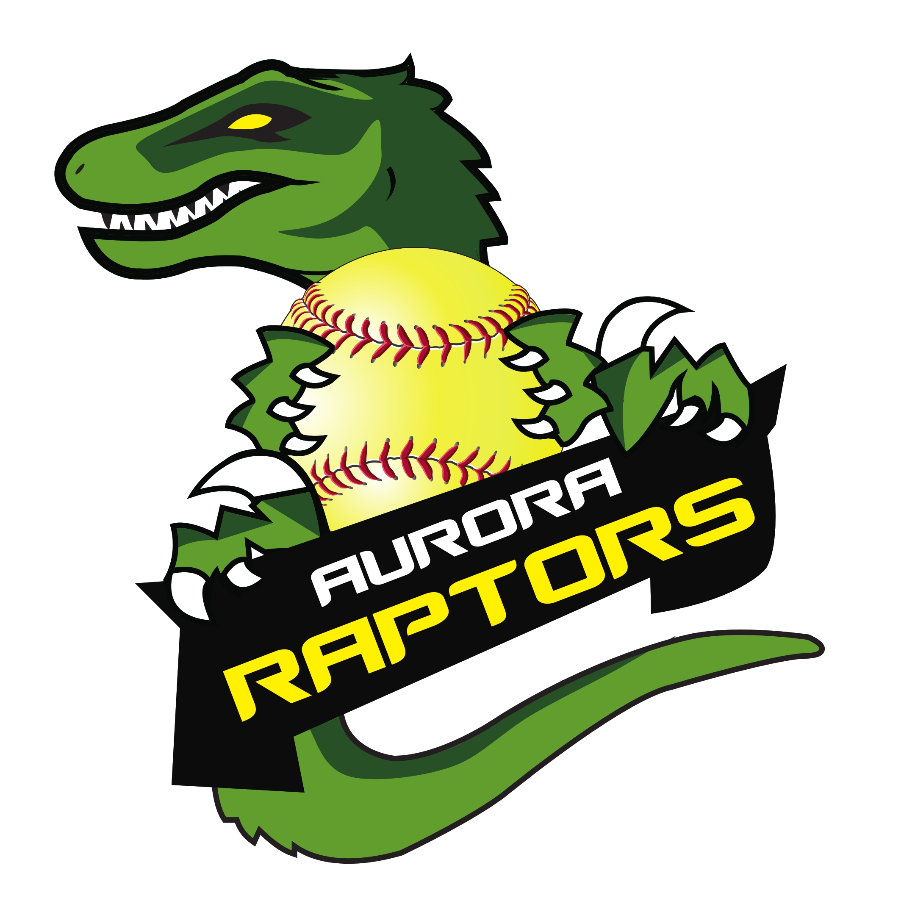
History: The Aurora Raptors started serving Aurora’s young female athletes in 1998. Our mission is to train and develop these athletes, so they are prepared to excel at the high school level.

Organization: We are a non-profit organization made up of volunteer directors and coaches. Every dollar that comes into the program is earmarked toward the development of the players. Coaches and directors pay the same fees for their child to participate. Our outstanding partnerships with the City of Aurora and the Aurora Schools allow us to provide a healthy atmosphere for player development. We value these partnerships and work hard to maintain them. Our softball program is designed to improve each player's technical ability which includes improving their fundamentals, speed, conditioning, and knowledge of the game that will take them to the next level.

Overview: Aurora Raptor Travel Softball falls into a category between recreation ball and tournament ball. It allows girls to participate in a more competitive environment with community friends without making a bigger commitment to tournament ball. Teams are typically built in the Fall so we are prepared to get started once the new year begins.

Parent & Player Expectations

The Raptors expect players to make a concerted effort to attend all winter program activities which run January thru March and are typically held indoors at D-Bat in Solon or Aurora High School. However, we recognize several players participate in other activities and sports. As a result, we encourage all players to participate in their “in-season” sport. Please communicate all conflicts with your daughter’s coach.

Once we reach the heart of the softball season, the Raptors program and coaches expect softball to become their main priority. Without this commitment during April, May, June, and July, the success of your daughter and the team will suffer. Missed softball activities will affect your daughter’s playing time at the discretion of the head coach.

League: The Aurora Raptors participate in the Western Reserve Fastpitch League. It is a league made up of surrounding communities who have the same mission as our program. Teams will normally play between 15 and 20 games per season plus playoffs. The spring season runs May thru July. Teams will typically play two games a week (Mon-Fri., 6:30pm start times) and practice at least once a week (typically on the weekends). Weekend Tournament participation is determined by the teams makeup and head coaches discretion. Fall ball in August-September is optional but it’s something we encourage to further their development.

Fees: All Raptor teams are self-funded. All fees collected are maintained in an account for the benefit of the organization. Fees are $350 for the season. Fees cover uniforms (jersey, pants, socks and belt), league fees, umpire fees, insurance, city fee, and all indoor gym time. They do not cover players equipment nor tournaments the head coach and families agree upon.

State of Aurora Raptors: The program has been healthy throughout its 21 year duration. Teams consistently compete in their leagues and produce very good players for the high school program. The evolution of softball has been such that players who become good in their community rec. programs usually look for more and move on to travel teams. Eventually some of our girls will move on to the tournament world and this exodus creates opportunities for more girls in the community to join our program and develop their skills. We are looking to re-build teams this year at the following levels:

10u: 8-10 years old on January 1st, 2023
12u: 11-12 years old on January 1st, 2023
14u: 13-14 years old on January 1st, 2023

We would like your daughter to consider becoming a Raptor. If you are interested, please contact me at auroraraptorssb@gmail.com for more details. Team building starts in the Summer during our open tryouts and team rosters are then set so we can prepare for our upcoming season.

Thanks,
Mark Collis
Email: auroraraptorssb@gmail.com

Website: https://tshq.bluesombrero.com/auroraraptorssball
Follow Us on Facebook: https://www.facebook.com/AuroraRaptorsSoftball/ or
Twitter: https://twitter.com/AuroraRaptors

President: Mark Collis
Aurora High School Varsity Coach: Sam Petrash

