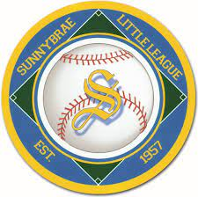

2026 Sunnybrae Little League
Board of Directors
President | Dan Pieszchala
Treasurer | Sean Kelleher
VP of Baseball Ops | Gary Leonardo
VP of Grounds | John Leonardo
VP of Admin | Tom Fink
Player Agent | Matt Sweeney
Trustee | Mike Gliottone
Trustee | Justin Girard
Trustee | Bob Little
Trustee | Josh Bell
Trustee | Dana Herrera
Trustee | John Leonardo
Trustee | Jim Maguire
Trustee | Jerry Herrera
Trustee | Paul Scheps
Trustee | Mike Morin
Trustee | Danny Mattonelli
Trustee | Phillip Treague
Trustee | Keith Wilson
Trustee | Jay Danley

