2018
DEER PARK LITTLE LEAGUE
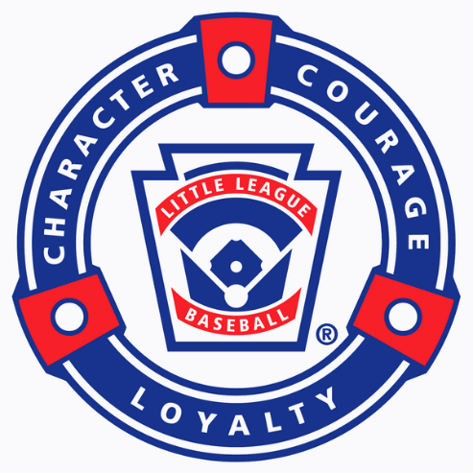
RULES BY AGE GROUPS

Please be sure to read through all the rules outlined herein as they are changed yearly

OVERALL RULES – ALL AGE GROUPS

- ABSOLUTELY NO “ON DECK” BATTERS AND NO SWINGING BATS IN THE DUGOUT!

- ALL CHILDREN MUST WEAR BATTING HELMETS – NO EXCEPTIONS! IF A PLAYER DOESN’T HAVE A HELMET, PLEASE ASK AT THE FIELD HOUSE TO BORROW ONE FOR THE GAME.

- HOME TEAM USES THE FIRST BASE DUGOUT.

- THE HOME TEAM IS RESPONSIBLE FOR GETTING A GAME BALL AS WELL AS BRINGING OUT AND RETURNING THE BASES.

- THE VISTING TEAM IS RESPONSIBLE FOR BRINGING OUT THE UMPIRES EQUIPMENT (FOR THE 8 Y/O GROUP) AS WELL AS RAKING AROUND ALL THE BASES AND PITCHES MOUND AFTER EACH GAME.

- MAKE SURE THE KIDS HAVE THEIR NAMES IN THEIR HATS AND ON THEIR BATTING HELEMTS AND GLOVES. THIS SAVES A LOT OF TIME IN BETWEEN INNINGS AS WELL AS AT THE END OF THE GAME.

- ALL MANAGERS AND ASSISTANT COACHES MUST FILL OUT THE VOLUNTEER FORM AND ARE SUBJECT TO A BACKGROUND CHECK.

- ONE ASSISTANT COACH SHOULD ALWAYS BE IN THE DUGOUT WITH THE KIDS

- FOR GOOD TIPS ABOUT COACHING VISIT THE LITTLE LEAGUE UNIVERSITY WEBSITE: http://www.littleleagueu.org/

DEER PARK LITTLE LEAGUE
5 & 6 YEAR OLD RULES

GENERAL:
- DO NOT keep score. When the kids ask, the game ended in a tie score. This is NOT a competitive division: This is an INSTRUCTIONAL division.
- Game length is an hour and 30 minutes or 3 innings.
- There should not be more than 1 manager and 3 assistant coaches helping in the game.

OFFENSIVE RULES:
- The batting tee is placed in front of home plate.
- Have the Manager/Coach behind home plate to assist the positioning of the batter at the plate. A Manager/Coach should be at first base to make sure the batter runs through first base, touching the orange part of the safety base. If available, a Manager/Coach should be at third base guiding the runners.
- The assistant coach in the dugout should line up the players along the fence in the batting order and stay at the opening of the dugout. Every kid that shows up to play should be in the lineup. If a kid shows up after the game started, the kid should be added to the bottom of the lineup.
- Each player bats until contact is made and the ball is hit into fair territory. If the batter only dribbles the ball a few feet in front of home plate, let them hit again.
- On a ball hit to an infielder, the batter will stop at first base. Each base runner will advance only one base.
- On a ball hit into the outfield over the infielder’s head, the batter may advance two bases only, even if the ball goes all the way to the fence.
- If the ball is hit and the defensive team records an out, the runners will remain on the base.
- After the entire team has batted, the half inning is over.
- Every game should utilize a different batting order.
- If toward the end of the season, the Manager/Coach is pitching to the batter, there will be a max of 4 pitches. If after 4 pitches the ball is not put in play, the batter must hit off the tee.

DEFENSIVE RULES:
- Position the players in both the infield (including the pitcher’s mound) and outfield.
- There should be no more than 3 adults on the field helping the defensive team.
- There should be at least one adult helping on the infield and one adult helping on the outfield.
- Every player should play in both the infield and the outfield during a game.
- Every player should have the opportunity to play all positions during the season.

DEER PARK LITTLE LEAGUE
7 YEAR OLD RULES
GENERAL:
- Do NOT keep score. When the kids ask, the game ended in a tie score. This is NOT a competitive division: This is an INSTRUCTIONAL division.
- Games will be over after 1 hour 55 minutes.
- There should not be more than 1 manager and 3 assistant coaches helping in the game.

OFFENSIVE RULES:
- Manager/Coach pitches to his/her own team.
- Pitch from the pitchers rubber on the mound or in front of it.
- Pitch overhand to the children.
- Have a Manager/Coach behind the catcher to assist in positioning the batter.
- The assistant coach in the dugout should line up the players along the fence in the batting order and stay at the opening of the dugout. Every kid that shows up to play should be in the lineup. If a kid shows up after the game started, the kid should be added to the bottom of the lineup.
- Batters will have a max of 5 pitches to put the ball in play, if not successful, it should go back to hit off the tee. There are no walks.
- RULES FOR HITS:
INFIELD HITS (GROUND BALLS / POP UPS / LINE DRIVES) > If safe, the runner will stop at first base (unless there is an overthrow, then the runner may advance one (1) base to 2nd base).
OUTFIELD HITS (FLY BALLS TO THE OUTFIELD GRASS (OVER THE INFIELDERS HEADS)) > If safe, the runner will be allowed to advance extra bases until the ball is relayed to the cutoff man – at this point the play is over. Baserunners in between bases will advance or return to the nearest base.
- NO sliding into first base for the children’s safety. To help enforce this rule, the batter will be called out. NO head first slides into any other base.
- The half inning is over when three (3) outs are made or 5 runs scored.
- Continuous batting order MUST be used each game. A different batting order must be used for each game. Switch the lineup each game so a different player leads off each game, a player doesn’t always bat last or in the same position in the lineup each game.
- Teach the children not to throw the bat. It is dangerous to the catchers. As they get older, they will be called out by the umpires.
- If Mangers/Coach is not available, use the other parents or older siblings to help coach the bases.

DEFENSIVE RULES:
- Switch your defensive players in every inning.
- Ten (10) players will play the field each inning (4 outfielders). For the children’s safety, only one (1) infielder simulating the pitcher (as a fielder) shall play near the pitcher’s mound. All other fielders will play their positions in the normal infield, outfield and catchers position, however the shortstop and/or the 2nd baseman may advance up to the grass portion of the infield, but just in front of the base-paths until the ball is in play.
- All catchers must wear athletic supporter (cup) – this is a mandatory rule!
- Teach the fielders to throw the ball to first base on ground balls. Even though they will be able to step on a base (force out) or tag the runner out, we want the children to get used to throwing to first base. For balls hit to the outfield, teach the fielders to throw the ball to the cutoff with relay to the pitcher. Force outs at 2nd, 3rd and home base are allowed.
- Use a catcher if you can. If no one wants to catch, don’t force them.
- Coaches will be allowed on the field during the first half of the season to help accommodate the players. After that, the players should know where to go on the field.
- NO PLAYER SHOULD SIT 2 INNINGS IN A ROW
REMEMBER – THIS IS A NON-COMPETIVE AGE GROUP (WE DO NOT KEEP SCORE).
WE ARE HERE TO TEACH THE CHILDREN HOW TO PLAY BASEBALL PROPERLY.
MANAGERS (PITCHERS) WILL ACT AS UMPIRES AND MAKE SAFE/OUT CALLS DURING THE GAME. IF A PLAY IS CLOSE, THE BASERUNNER SHALL BE CALLED SAFE (UNLESS BLATENTLY OUT).

DEER PARK LITTLE LEAGUE
8 YEAR OLD RULES

GENERAL:
- Umpires will NOT be provided. Both teams will supply an umpire using a Manager/Coach or knowledgeable adult. A strike should be a hittable pitch even if it is a little inside/outside the strike zone. Do not call strike over the batters shoulders.
- 8 year old pitchers will have trouble getting the ball over the plate so the strike zone should be a little bit wider than normal. Do not argue over the strike zone and be fair!
- Any player hit in the head with or without a helmet will be evaluated on the field and a decision will be made before returning to the game.
- There should not be more than 1 manager and 3 assistant coaches helping in the game.
- Line ups must be exchange before the game starts and should include both the player name and number.

OFFENSIVE RULES:
- NO bunting.
- NO stealing.
- NO infield fly rule.
- NO sliding into first base.
- NO head first slides except back to last base touched.
- Teach the children the proper way to slide.
- Tagging up is allowed.
- Continuous batting order MUST be used each game; bat the children in a different slot each game. The same children should not bat 3-4-5 or 11-12-13 every game.
- Teach the children not to throw the bat. It is dangerous to the catchers. As they get older, they will be called out by the umpires.
- No parents or other children are allowed in the dug outs. Just the Managers/Coaches and players.
- Get the children to swing the bat. Teach them the proper way to swing at hittable pitches. Don’t have the kids intentionally taking pitches! Swing Away!
- WALK RULE: No more than four (4) walks per inning. A batter who is hit by a pitch is considered a walk. After four (4) walks in an inning the pitcher must be removed and the rest of the offensive team must hit or strike out – no more walks will be issued.
- An inning is over after three (3) outs or 3 runs, except for last inning (not necessarily the 6th inning).

DENFENSIVE RULES:
- No pitcher shall throw more than fifty (50) pitches in a day. If a picture hits two (2) batters in an inning or three (3) batters in a game; he must be removed from the game as a pitcher.
- If a player is removed from the pitcher position, that player can’t return to pitch again in that game.
- Follow PITCH COUNT RULES for proper rest period.
- Ten (10) players on the field, four (4) outfielders.
- Managers/Coaches children must sit out as much as everyone else. Give all the kids a chance to play all defensive positions, with one (1) exception, as a safety issue, please only let kids play 1st base that know how to catch the ball, it is a position that a child could get seriously hurt if they do not know how to catch the ball.
- Pitchers MUST pitch from the rubber on the mound (46” from home plate). NO EXCEPTIONS! This is an official Little League Rule and a serious safety issue. DO NOT let the kids pitch from a shorter difference!
- If a pitcher walks 4 kids in an inning, the pitcher must be replaced. For the first half of the season, the offensive coach can finish that inning and bring a new pitcher to start the next inning. For the second half of the season, only players will be allowed to pitch, no coach can finish the inning.
- If the pitcher reaches 50 pitches and he is in the middle of an at bat, he is allowed to finish that batter.
- A pitcher that throws 41 or more pitches in a game cannot play the position of catcher on the same calendar day.
- A catcher that plays the position for more than 3 innings in a game is not eligible to pitch on the same calendar day.
- If a team has only 8 players available to play defense, may borrow the player that made last out or last batter from the other team for defense. However that borrowed player will still be part of his team’s line up.
- NO PLAYER SHOULD SIT OUT 2 INNINGS IN A ROW

8 YEAR OLD PITCH COUNT RULES
1 – 20 NO REST PERIOD REQUIRED
21 – 35 ONE (1) CALENDAR DAY
36 – 50 TWO (2) CALENDAR DAYS

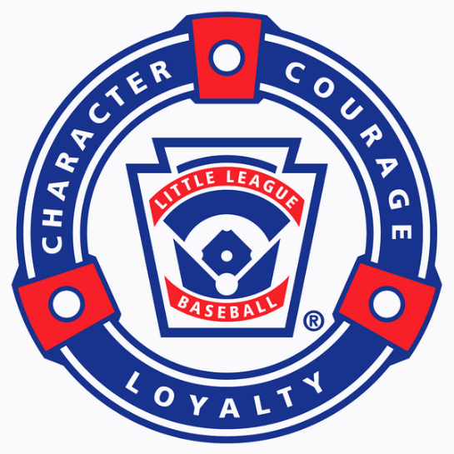

Deer Park Little League
9/10 Minors Division Rules

- 6 Inning Games
- 2 Hour Time Limit – Confirm start with coaches prior to first pitch
- No new inning after 1:50. If time allows, extra innings can be played, but games can end in a tie.
- 12 Run Mercy Rule in effect after the losing team has batted a minimum of 4 times. If the away team goes ahead by 12 runs after the 4th, the home team must be given an opportunity to bat.
- Pitchers must be removed if they hit 2 batters in an inning, 3 batters in a game.
- Ball must reach batter before a steal attempt is made. Runners who leave early are sent back.
- No leading
- 4 Steals max per inning. Double steals count as 2 stolen bases.
- Runners may Not Steal Home on a passed ball or wild pitch but all other plays are legal.
- Runners may not advance on over-throws on steal plays, but all other plays are legal.
- No dropped third strike rule.
- Infield Fly rule is in effect.
- Players may enter the lineup and game at any time, but they must be placed at the bottom of the batting order.
- All players must wear a helmet and all players except the batter and base runners must remain in the dugout. There is NO On-Deck batter.

Deer Park Little League
11/12 Minors Division Rules

- Regular little league rules are in effect in exception to the following rule:

- 12 Run Mercy Rule in effect after the losing team has batted a minimum of 4 times. If the away team goes ahead by 12 runs after the 4th, the home team must be given an opportunity to bat.

