2024 ASAP Safety Manual

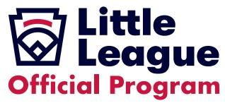

Williams Little League

This Page is intended to leave Blank

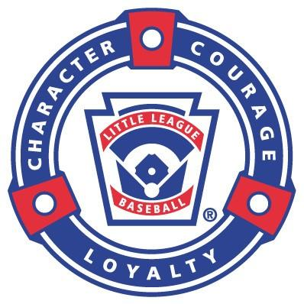

Safety Mission Statement
It is the policy of Williams Little League to actively participate in the A Safety Awareness Program (ASAP) to safeguard the physical and emotional well-being of all children participating in any baseball and softball programs, as well as providing a safe and friendly environment for volunteers, parents and spectators. It is also the policy of our league to
- Inform and educate our community as to what the ASAP Program is and how it serves the best interests of our participants
- Involve players, parents, community members, local businesses, law enforcement, fire protection, Emergency Medical Services (EMS) and other organizations in our ASAP Program through the sharing of information, poster campaigns, advertising and education programs
- Utilize all available resources within our community to further the goals of the ASAP
- Make Zero-Injuries our goal

Table of Contents
Safety Mission Statement 3
A Safety Awareness Program (ASAP) Safety Manual 5
2024 Safety Training Events 5
Safety Officer 5
2024 Safety Officer Contact Information 6
Player Safety 6
Child Protective Policy 6
Volunteers and Background checks 6
Professional Photography 6
Little League Medical Release Form 6
For Managers and Coaches 7
OUR LEAGUE’S EMERGENCY PROCEDURE 8
DIAL 9-1-1 8
Emergency Injury or Illness 8
Enforcing Little League Rules 9
Local Leagues Safety Rules 10
Fundamentals Training 10
First Aid Training 10
Field Inspections 10
Equipment Inspection 10
Safety Equipment 10
First Aid Kits 10
Concession Stand Safety 10
Concession Stand Policies and Guidelines 11
COVID-19 12
Everyday Hygiene Guidelines (Low & Medium Levels): 12
Protocol for High Levels 12
Accident Reporting Procedure 12

A Safety Awareness Program (ASAP) Safety Manual
The ASAP mission is to increase awareness to provide a safer environment for children, volunteers, and all Little League participants. Having a league safety program is instrumental to the well-being of players, volunteers and all participants. The Little League ASAP program encourages individual leagues to create a safety manual. Williams Little League is committed to the safe operation of our programs. This Safety Manual has been developed to assist in that effort and to ensure that our league is “ASAP” compliant. This safety manual will be distributed to all Managers, Coaches, Umpires, League’s Board of Directors, and all other volunteers. Parents shall be informed of the ASAP through managers and/or Safety Officer.

2024 Safety Training Events
Williams Little League requires Safety training. Each team shall have at least one Manager or Coach that is certified in 1st Aid CPR and/or the CDC Concussion Training. Copies of certification shall be provided to the league and within managers binders. The following explains where training can be obtained.
- Red Cross First Aid CPR Training
  - https://www.redcross.org/take-a-class
- CDC Concussion Training
  - Link to: HEADS UP to Youth Sports: Online Training | HEADS UP | CDC Injury Center
  - https://www.cdc.gov/headsup/youthsports/training/index.html
- 2024 Fundamental/Skills and First-Aid/Safety Training Sessions
  - First-Aid and Safety Program Training: March 16th 2024
  - March 2nd and April 6th - Skills Assessment
  - Umpire Clinics: Local TBD and Prescott Clinic March 25th 2024
- 2024 Mandatory Child Safety Training requirements of each Head Coach, Assistant Coach and Team Parent/Team Helper/Team Parent Coordinator
  - Abuse Awareness Training - Provided by USA Baseball - LittleLeague.org - Child Protection Awareness
-Training to be provided at Division Coaches Meetings pre-season.
- Mandatory Little League training for coaches: Diamond Leadership Training
  - Training certificates will be printed and retained in the team binder

Safety Officer
The responsibilities of the Williams Little League Safety Officer are:
- Develop and document League Safety Program and distribute copies to all volunteers in accordance with ASAP policy
- Submit a yearly ASAP plan to Little League
- Submit annually an updated Facilities Survey to LLBB
- Ensure compliance throughout the league with the established safety policies
- Help develop and coordinate all Safety Related Training with the League
- Conduct regular inspections of all fields and facilities
- Report all violations to our Little League Board of Directors along with the corrective actions taken
- Investigate all accidents; provide claims forms and information and track in accordance with this safety manual
- Make sure all teams have First Aid Kits at all games and practices
- Ensure league compliance with the Little League Baseball’s Child Protection Policy
- Ensure compliance with ASAP requirement 14 requiring player registration data and coach/manager data be submitted via the Little League Data Center
- Submit any ideas implemented by our league to help improve our safety plan

2024 Safety Officer Contact Information

Name: Danielle Sanders
Cell: (928) 310-6644
Email: Nellie12407@gmail.com

Player Safety

Child Protective Policy
Little League has zero tolerance for any type of abuse against a minor, including, but not limited to, sexual abuse, physical abuse, mental, and emotional abuse (as well as any type of bullying, hazing, or harassment). Any individual with an offense involving or against a minor (refer to Volunteer Application), will not be permitted to participate in any Little League programs or activities. The Williams Little League shall enforce and establish a zero-tolerance culture that does not allow any type of activity that permits or promotes any form of misconduct or abuse (mental, physical, emotional, or sexual) between players, coaches, parents, guardians, caretakers, spectators, volunteers, and/or any other individual.

Volunteers and Background checks
- Our league will conduct background checks on all Volunteers. Final approval is by the League’s Board of Directors. There will be absolutely no exceptions to this requirement. Please refer to the 2024 Williams Little League Bylaws on a full description of the background check process.
- All Volunteers shall be cleared through the Little League background check process required by Little League International thru J.D. Palatine (JDP). Anyone refusing to follow and complete the required process will not be allowed to participate with the league in any capacity. Please see Volunteer Application in Appendix A.
- No one will be allowed on fields or in dugouts without a completed Williams Little League background check.

Professional Photography
The purpose of this rule is for the safety of the Players. Professional photography is defined by the league as payment, indirect payment, reimbursements, or donations for: pictures of Players or photography of activities within the league. Newspapers and media organizations are exempt from the following rule. No person shall provide professional photography for Williams Little League unless approved as a vendor through Little League® International and approved by the Leagues Board of Directors.

Little League Medical Release Form
The Williams Little League requires that the Little League Medical Release be completed, signed, and returned to the team manager before participation in any practice or game. There are no exceptions to this rule. Copies shall also be provided to the Player Agent. A blank copy will be provided with the registration forms and/or team Managers.
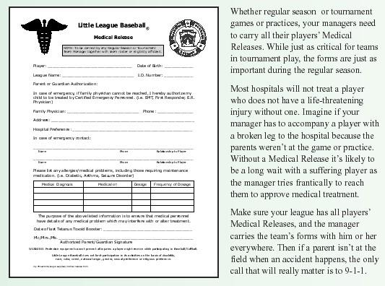

For Managers and Coaches: Quick Stop
This section is a quick checklist for managers and coaches to ensure safety on a daily basis.
- Ensuring safe Facilities
  - Fields, dugouts, batting cages, bathrooms, ect. checked prior to Games or Practice
- Manager Binder
  - Locations for Safety Information
  - Contact Information
  - Emergency Forms
  - All Players Medical Release forms and Parent Code of Conduct Form
- Require stretches and Warmups prior to practices and Games
  - Warmups should include gradually increasing working through the full range of motion for the activity expected and should include a sport specific activity. Lining up and throwing to each other for 15 minutes is not a warmup!
  - Cool down after vigorous exercise. A 10-to-15-minute cool-down period allows heart rate and breathing to return to normal. Slow walking will prevent blood from pooling in the legs. Blood pooling can cause dizziness and blackouts. Coach may conduct stretching exercises again to prevent the muscles from getting sore and stiff.
- Little League Rule Book
  - Rule Changes
  - Game Pitch Counts per Age Group and Pitching Mechanics
- Weather Policy
  - 30 Minute Delay for Lighting Conditions
- Players Returning from Injury
  - Managers and Coaches responsibility to ease players back into practices and games.
  - Managers and Coaches may decide for player may have less of a playing role in the team to recover
- Injury Prevention
  - Every activity or action shall have safety as a number one priority.

OUR LEAGUE’S EMERGENCY PROCEDURE
In the event of any emergency such as a serious injury, illness, crime, threat of any type, then Dial 9-1-1

DIAL 9-1-1
This will connect you to a dispatcher who will provide the appropriate response to any emergency. Listen carefully to the dispatcher. They will ask you the appropriate questions and get you the help you need. No matter what, DO NOT HANG UP until the dispatcher hangs up or tells you to.

Emergency Injury or Illness
If the emergency is an injury or illness, follow this procedure

- First, protect the victim from further injury! DO NOT MOVE THE VICTIM UNLESS THERE IS AN IMMEDIATE THREAT!

- Any qualified person at the scene should provide First Aid immediately.

The most important help you can provide to a victim who is seriously injured is to call for professional medical help. Make the call quickly, preferably from a cell phone near the injured person. If this is not possible, send someone else to make the call from a nearby telephone.

- First dial 9-1-1. Give the dispatcher the necessary information. Answer any and all questions that he or she might ask. Most dispatchers will ask your exact location, the telephone number from which the call is being made and your name. They will also need to know what happened, how many victims there are and their condition. They will also ask what help is being given (first aid, CPR, etc.) The dispatcher may be able to tell you how to best care for the victim.

- Continue to care for the victim and reassure them until professional help arrives.

- If the victim is a minor, find the legal guardian.

- Always notify the League President and/or Safety Officer of any incident, no matter how minor, so that it can be properly documented by the league.

League President – Jenni Rigo 602-677-7314
League Safety Officer - Danielle Sanders 928-310-6644

Enforcing Little League Rules
All rules of the 2024 Little League Rulebook (Little league International Rules) will be strictly enforced. Our league will ensure that every manager, coach, umpire, and league/district official will have access to the 2024 Little League Rulebook. Williams Little League encourages the download of the 2024 Little League Rulebook App. All participants shall adhere to the Little League Rulebook during games and practices as most rules relate to safe participation. Some rules of special importance
- Catchers will be properly equipped In accordance with Rule 1.17. All catchers shall also have dangling throat protectors secured to their masks in such a way as to provide proper protection
- Catchers warming up pitchers or catching for infield/outfield drills will wear catchers helmet, mask with dangling throat protector
- Rule Book 3.09 -Managers or coaches are permitted to warm up a pitcher at home plate or in the bullpen or else ware at any time, including in game warm-up, pregame warm-up, and in other instances. They may also stand by to observe a pitcher during warm-up in the bullpen.
- All equipment will be inspected before it is issued and before each use. All batting and catchers helmets will comply with all specifications and applicable NOSCAE standards
- All suspect or clearly defective equipment will be disposed of by our equipment manager. It will not be given away for use by anyone
- All bats used by our league will fully comply with 2024 Little League rules

Local Leagues Safety Rules
- Every Manager is to carry the team’s roster with copies of all Medical Release Forms to all games and practices.
- Umpires are a vital part of our Safety Program. Umpires will be considered Safety Officers for each game they officiate in the absence of a District or League Safety Officer and have the authority to stop, or delay play due to any safety issues

Fundamentals Training
- Draft dates will serve as fundamentals training. Other online resources will be provided to coaches. Clinics will be provided as they come available.

First Aid Training
- Annual Basic First Aid/EMT Training is mandatory for our coaches and managers. All umpires and league officials will also be required to attend.

Field Inspections
- Before any game or practice, Managers, Coaches and Umpires will carefully inspect the fields/facilities for hazards. Inspection should include bases, fences, outfield area, restrooms, and bleachers. Managers shall also ensure that all phone listings for our Little League Board of Directors and all Emergency Phone listings are predominately posted at the game or practice site. Report all problems to the League Safety Officer. Correct all problems BEFORE beginning play or practice.

Equipment Inspection
- Before any game or practice, all equipment (Bats, Helmets, Bases, Catchers Equipment) shall be carefully inspected for defects. Discard all defective equipment and report all problems to the Safety Officer. All defective equipment will be returned for permanent disposal. At no time will defective equipment be given away.

Safety Equipment

First Aid Kits
- Every Manager is to ensure that a First Aid Kit is available for all games and practices. Managers will also be sure to carry the team first aid kit if traveling outside of the league facilities. All kits should include non-latex gloves.

Concession Stand Safety
Williams Little League will operate concessions at Williams Cureton Park City Little League Field and as needed Williams High School Field. Operations will be inspected by our Board on a regular basis.
- Our league will post and distribute written safety procedures for our concession operations
- Our league concession manager shall be obtain a food handlers card and a copy shall be posted in the concession stand
- Our league concession manager trained in safe food handling/prep procedures shall train league volunteers working in concessions
- Our Training will include
  - Proper perishable food storage and handling guidelines
  - Proper food preparation guidelines
  - Procedures for inspection of all food storage equipment
  - Safety rules for operation of grills or other potentially dangerous equipment
  - Concessions check lists for opening and closing concessions

Concession Stand Policies and Guidelines
Policy
- All concession volunteers shall have training in basic safety guidelines for concessions
- Unwrapped foods are only served by individuals with a food handlers card;
- Grills/Hotplates may not be attended by anyone under the age of 18 without proper supervision.
- All other concessions volunteers handling unwrapped food shall be at least 14 years of age.
- Concessions volunteers will inspect the concession area for any violations of the posted safety requirements and report any irregularities to a board member.
- Concession manager, board member or the volunteer in-charge of the concession stand will verify before daily operations the following:
  - Only authorized volunteers are to be in the concessions area during operations
  - Fire Extinguisher and First Aid Kit is in place, stocked and in working order
  - Emergency Phone Numbers posted
  - Cleanliness of the food preparation area completed and free of any unsafe or unsuitable items such as cleaning fluids, debris, etc
  - Food storage and preparation equipment are in proper working order
  - League Safety Manual is in the Concession Area
Guidelines
- At least one of the League’s Board of Directors shall be present in concessions stand during while open to the public;

COVID-19
Williams Little League shall apply advice from the Center of Disease Control (CDC) pertaining to Covid-19. The CDC provides Covid Community Levels based on Low, Medium or High Levels. The following explains how the Williams Little League will mitigate for Covid-19 during community levels.

Everyday Hygiene Guidelines (Low & Medium Levels):
- Players, coaches, umpires, spectators, and volunteers will take precautions related to COVID-19.
- Wash hands before and after team activities, hand sanitizer will be provided to the extent possible
- No individuals should attend team activities if they are showing virus symptoms
  - https://www.cdc.gov/coronavirus/2019-ncov/symptoms-testing/symptoms.html
- Families are responsible for assessment of player health prior to each team activity
- Managers and Coaches should notify players guardian if player arrives showing symptoms
- Minimize direct contact and maximize physical separation/spacing
  - Players may wear a facemask during play or practice, but it is not required.
  - Players drink only from their own water bottles.

Protocol for High Levels
- Everyday Hygiene Protocols shall be followed
- Only one team on the field during practice.
- Dugouts will be rotated for each practice. i.e. 1st & 3rd practice will use Home dugout, 2nd practice will use Visitor dugout.
- Minimize shared equipment - players bring their own gear to the extent possible
- Equipment and dugouts should be sanitized to the extent possible.
- Parents are permitted to attend games. Spectators will be required to social distance. Children not playing will need to stay with their parents. All spectators will be required to wear a mask if not socially distanced.
- No sunflower seeds or gum allowed on fields, in dugouts and within stands.

Accident Reporting Procedure
All accidents and near-miss incidents shall be reported to the League Safety Officer.
- All accidents involving an injury that require any first aid or professional medical attention shall be reported within 24 hours of the incident;
- All other accidents and near miss incidents shall be reported within 72 hours. Near miss accidents are any incident where a player, spectator, umpire, coach, manager, or league official narrowly missed being injured. These “close call” incidents may indicate a safety problem that needs to be addressed before an actual injury occurs.
- The League Safety Officer will investigate and take appropriate action.
- Safety officer will also forward comments to the League’s Board of Directors and fill out appropriate form(s)
- ASAP Incident Tracking Form and Little League Accident Notification Form
- Safety office or another board member will also assist parents in filing claim forms. Copies of all claim forms will be maintained for two years. ▪ All accidents and near miss incident reports will be maintained by the board for a minimum of two years.
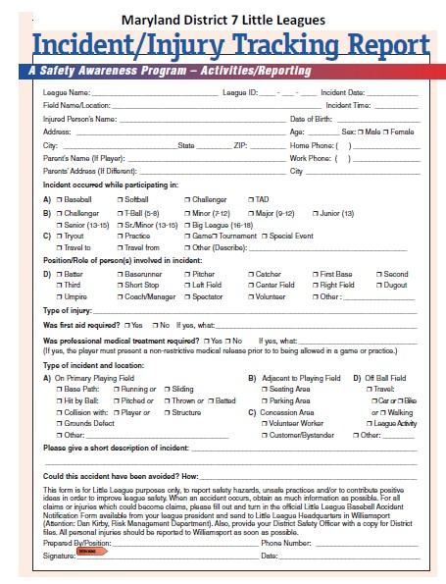
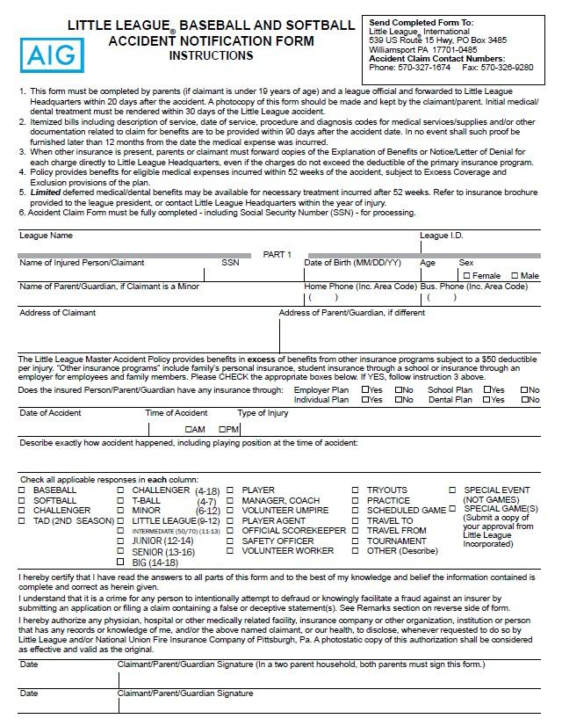
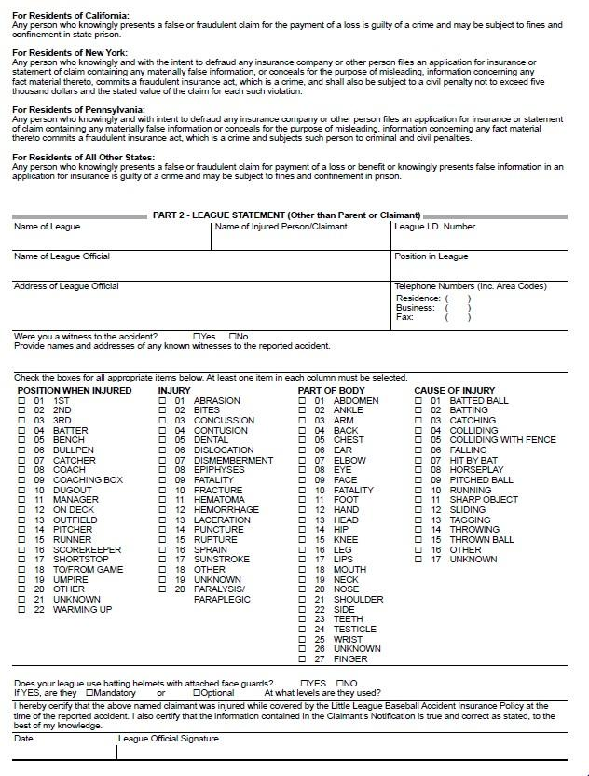

Williams Little League Volunteer Background checks and approvals shall/will only be processed by volunteers creating and account on williamslittleleague.com. Upon applying to volunteer each individual(s) background will be processed through JDP.

Examples of unapproved volunteer applications:

Appendix A: 2023 Little League Volunteer Application

