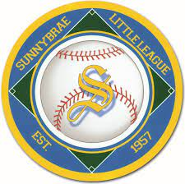

2024 Sunnybrae Little League
Board of Directors
President | Dan Pieszchala
Treasurer | Sean Kelleher
VP of Baseball Ops | Gary Leonardo
VP of Grounds | Dan Wheeler
VP of Admin | Jim Manning
Player Agent | Matt Sweeney
Past President’s Seat | Chris Drudy
Trustee | Tom Fink
Trustee | Justin Girard
Trustee | Bob Little
Trustee | Josh Bell
Trustee | Dana Herrera
Trustee | John Leonardo
Trustee | Jim Maguire
Trustee | Tony Marchetti
Trustee | Paul Scheps
Trustee | Dan Eagan
Trustee | Joe Furman
Trustee | Stef Marchetti
Trustee | Tom Brettell

