Support

Parents: Online Registration Instructions

Online Registration Instructions
Please read all instructions below to learn how to register your son or daughter.

Steps to complete online registration:
- Access www.grandchutebaseball.com and then click on Register in the top right hand corner of the site.
- If you are new to the club/organization, fill out the Create New Account section on the Login screen. Then click on Create Account.
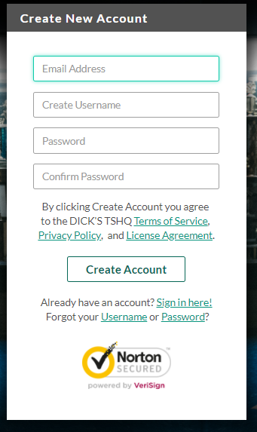
If you have previously created an account and registered on this specific website, then log in under the Sign in Here link.
Can't remember your username or password? Click the 'Forgot Username or Password' link to have these items sent to the email address you previously used to create this account.
Once you have logged in to your account, click the Programs Available! button next to your son or daughter's name and skip to Step 5. 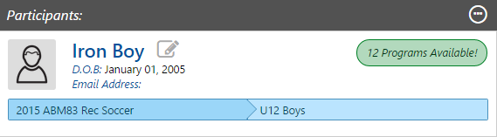
- Fill out the Primary Parent/Guardian Information section. If you wish to add a Additional Parent/Guardian’s email (to be cc’d on all Program related emails), enter their information in the Additional Parent/Guardian Information section and click Invite Account User & Continue. If not, leave the area blank and click Continue.
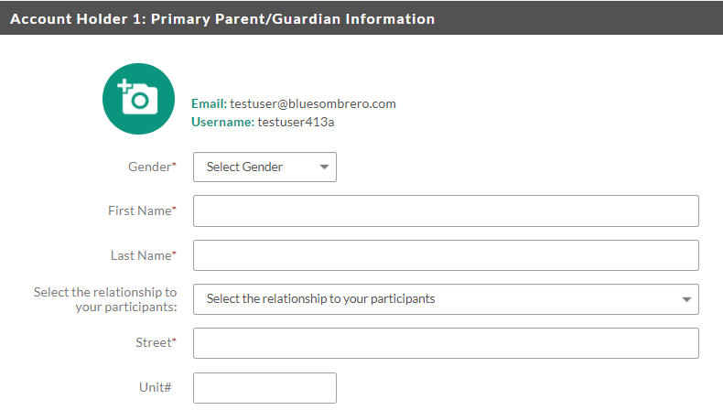
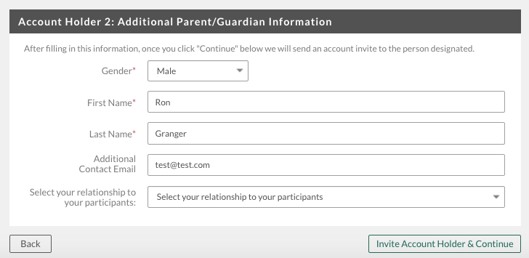
- If this is your first time registering on the site, you will see a pop up, asking you to describe what fits you best. In most cases, you will select the first option if you have a child you are trying to register. The middle option is if you are volunteering but DO NOT have a child participating on the site. The third option is if you are trying to register yourself for an activity.
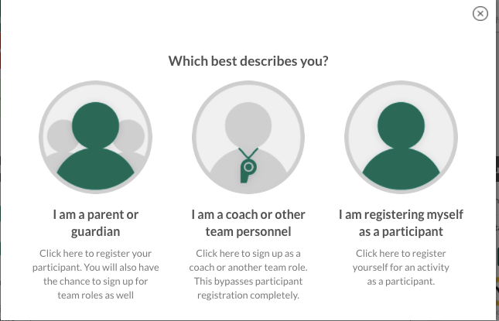
- Fill out the New Participant Inforamtion section. Make sure your son or daughter's birth date is set correctly or it might not fall within the division parameters the club's Administrator has set. Click on Continue.
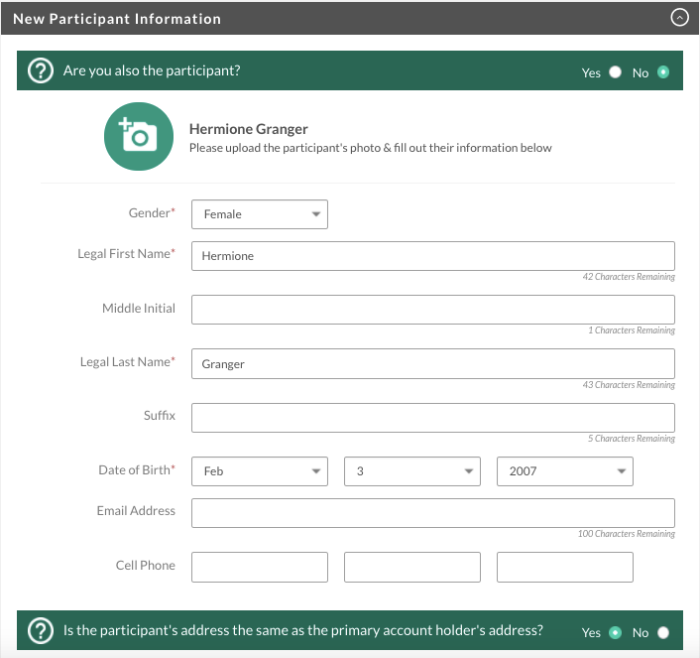
- Select the Program you'd like to sign your son or daughter up for. Click on Continue.
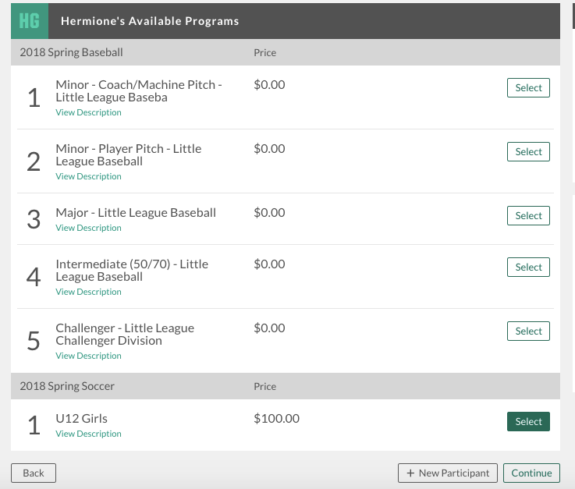
- Fill out all Registration Information. Click on Continue.
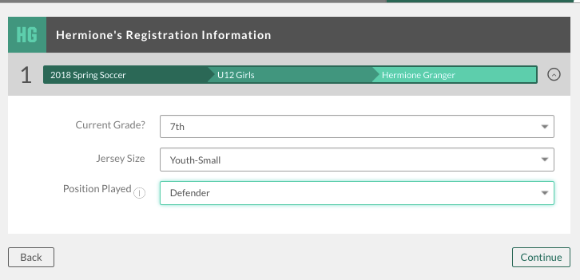
- Sign up to volunteer on the Available Positions page. Choose the position you’re interested in, and you will be prompted to complete information about the position. If you do not wish to volunteer, mark the appropriate box below. Choose Continue.
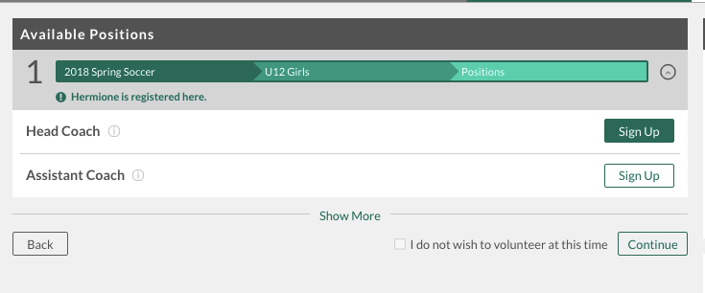
- The last screen is the Checkout screen. Review your Registration Summary, select your Payment Type, select your Payment Option (Pay in Full or Payment Plan if it is being offered), enter in Address and Payment Information, read and agree to the Terms & Conditions, and then select Submit Order.
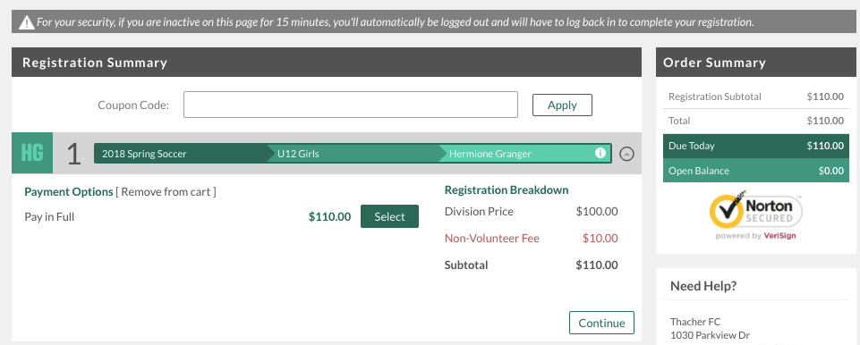
- After you submit your order, you will be brought to a Order Confirmation page. You will also receive a confirmation email, detailing your registration. 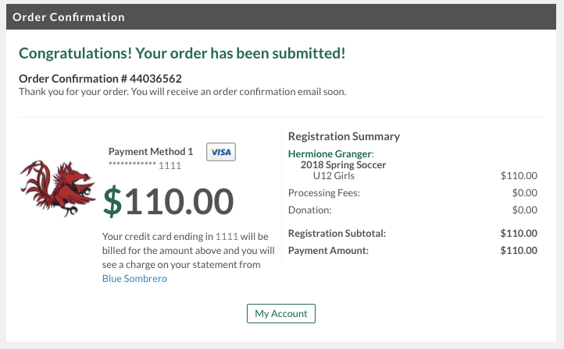
- You just completed the online registration process!
Need more help? Check out our Parent Registration FAQs.

