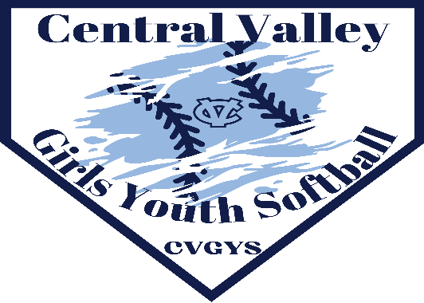 | Central Valley Girls Youth Softball Executive Board  Mark Aikens, President (724) 622-5586  Tracy Strickland, Vice President (724) 462-4523  Diana Powell, Treasurer (724) 601-4522  Ashlee Scassa, Secretary (724) 601-4678

2024 CVGYS SPONSORSHIP FORM
We are starting to plan for the 2024 Central Valley Girls Youth Softball Season and the support of our sponsors play an important role in the success of our program. We are always looking for assistance from all the local businesses in our area.

We will be utilizing our website (https://tshq.bluesombrero.com/cvgfp/) to encourage traffic and visibility to our website sponsors. There will be a league website, with individual team websites, as well as family websites. Your website ads will be visible across all our platforms.

Our 2023 Spring Season included 11 teams totaling 120 highly motivated girls who registered in our program. Our 2023 Fall Season brought us 9 teams totaling 100 girls. Our league continues to be one of the larger youth softball organizations in Beaver County and we need help financially to provide these girls a safe program to learn the game of softball.

Our program includes supplying our girls with helmets, bats, balls, catchers gear, first aid equipment, and umpires. We also provide safe playing conditions with field improvements. I also can’t forget the dedicated parents that volunteer their time to help make this program such a success.

Central Valley Girls Youth Softball League is a non-for-profit organization that works with the Central Valley Varsity program. This helps us to promote fast pitch softball in our area with hopes of developing these girls for future success at higher levels of softball.

Please complete and return this sponsorship form with a check payable to CVGYS and return to:

CVGYS
ATTN: Diana Powell (Treasurer)
131 Cottonwood Drive
Aliquippa, PA 15001

Thank you in advance for your support of Central Valley Girls Youth Softball.

Sincerely,
CVGYS Executive Board

Central Valley Girls Youth Softball Executive Board

Mark Aikens, President (724) 622-5586
Tracy Strickland, Vice President (724) 462-4523
Diana Powell, Treasurer (724) 601-4522
Ashlee Scassa, Secretary (724) 601-4678

2024 CVGYS SPONSORSHIP OPPORTUNITIES

Central Valley Girls Youth Softball is registered as a tax-exempt association, see below for Tax ID #.
Please include your business information for our website’s sponsor page.

HOME RUN SPONSOR - $600.00
- Website Business Page
- Field Banner
- Team Sponsor
- Wing Bash Sponsor
- Website Banner
- Sponsor Appreciation List

TRIPLE SPONSOR - $450.00
- Team Sponsor
- Wing Bash Sponsor
- Website Banner
- Sponsor Appreciation List

DOUBLE SPONSOR - $300.00
- Your choice of a Team Sponsor OR Website Banner.
- Sponsor Appreciation List

SINGLE SPONSOR - $200-$125
- New Field Banner - $200
- Banner Renewal - $125
- Sponsor Appreciation List

BASE ON BALLS SPONSOR - Any Donation
- Any donation in the form of cash or value will be accepted.
- Sponsor Appreciation List recognition

- Please CIRCLE your Sponsorship Level of Interest -
HOME RUN SPONSOR TRIPLE SPONSOR DOUBLE SPONSOR SINGLE SPONSOR

Business Name:
Primary Contact:
Contact Phone:
Contact Email:
Address:
Sponsorship Key
Website Business Page - We will provide a page on our website that can list your business contact information, business hours, and specials. As well as attach files of menus, coupons, etc.
Team Sponsor - Your Business will be assigned a team, and your business will be printed on the jersey.
Field Banner - This banner with your business information will be displayed at our field in Taddeo Park. Please provide design ideas.
Wing Bash Sponsor - Your Business will be one of our sponsors at our annual fundraiser.
Website Banner - Your Business Name, Contact Information, and an active link will be listed on a banner on our website’s front page.
Sponsor Appreciation List - Your Business Name will be listed on our websites Sponsor Page for 1 Year.
CVGYS organization is a non-profit 501(c)3 organization. Your donation is tax-deductible. Federal Tax ID # 92-1387248

