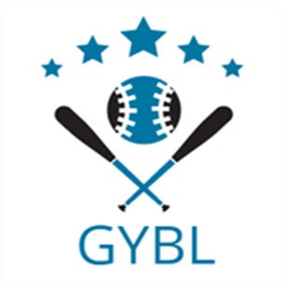
Greensburg Youth Baseball League Sponsor Packages:
Gold Sponsorship: Sponsor name and/or logo will appear on banner placed on the fence.
Cost: $135
Platinum Sponsorship: Sponsor name will appear on the front of team uniforms. Sponsor name will appear on schedules. Cost: $225 ($25 discount for each additional team sponsored)
Diamond Sponsorship: Combination of the Gold and Platinum Sponsorship.
Cost: $330 ($30 discount for doing team and banner)

501(c)(3) documentation can be found on our website: www.greensburgyouthbaseballleague.com

Sponsor Name: ___________________________________________________________

Sponsor Contact: __________________________________________________________

Affiliated Players and ages (Please list more than one so we can try to accommodate your request)

_________________________________________________________________________

Address: __________________________________________________________________

Phone: ______________________________ Email: ________________________________

Website: __________________________________________________________________

Sponsor Package Purchased:
_____ Gold Sponsorship Amount Enclosed: $ __________
_____ Platinum Sponsorship
_____ Additional Team Sponsorship
_____ Diamond Sponsorship

_____ Downloadable logo/artwork available for banner
Please send high resolution logo/artwork to the following email address: greensburgyouthbaseball@hotmail.com
If we do not receive logo/artwork by April 1st your banner will be printed with only your sponsor name as written on this form.
Please make check payable to Greensburg Youth Baseball League and mail check and sponsorship form to: 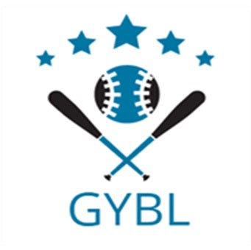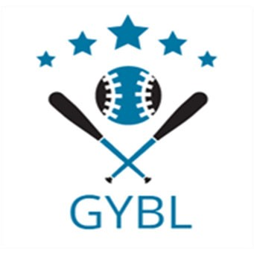

Greensburg Youth Baseball League
PO Box 544
Greensburg, IN 47240

Please Return This Sponsorship Form and Payment By

April 1, 2023

