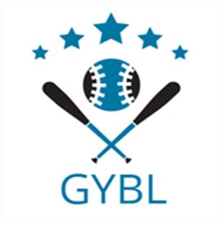 **Greensburg Youth Baseball League** **Sponsor Packages:**

**Gold Sponsorship:** Sponsor name and/or logo will appear on website & on our facebook page.

Cost: **$135**

**Platinum Sponsorship:** Sponsor name will appear on the front of team uniforms. Sponsor name will appear on schedules. Cost: **$225** ($25 discount for each additional team sponsored)

**Diamond Sponsorship:** Combination of the Gold and Platinum Sponsorship.

Cost: **$330** ($30 discount for doing team and logo on our website & on our facebook page)

501(c)(3) documentation can be found on our website:  **www.greensburgyouthbaseballleague.com**

Sponsor Name: ___________________________________________________________

Sponsor Contact: __________________________________________________________

Affiliated Players and ages (Please list more than one so we can try to accommodate your request)

_________________________________________________________________________

Address: __________________________________________________________________

Phone: ______________________________ Email: ________________________________

Website: __________________________________________________________________

Sponsor Package Purchased:

_____ Gold Sponsorship Amount Enclosed: $ __________

_____ Platinum Sponsorship

_____ Additional Team Sponsorship

_____ Diamond Sponsorship

_____ Downloadable logo/artwork available for banner

Please send high resolution logo/artwork to the following email address: **greensburgyouthbaseballleague@gmail.com**

Please make check payable to Greensburg Youth Baseball League and mail check and sponsorship form to:



Greensburg Youth Baseball League

PO Box 544

Greensburg, IN 47240

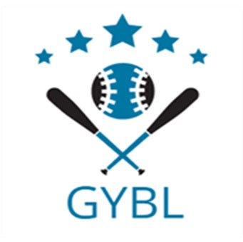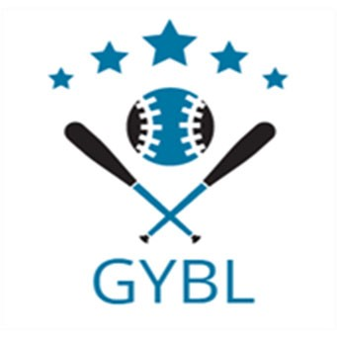

The Greensburg Youth Baseball League is a not-for-profit organization that provides structure, leadership, and a positive approach for the youth of Decatur County, that desire to play the game of baseball. The GYBL registers around 340 players ages 4 – 13 each year. It is our goal to see that number grow for the 2025 season and to do so we need your help. The GYBL is funded solely on registration fees, grants, donations, and sponsorships. We have goals to provide our youth with the best possible opportunities to play baseball. In order to make the improvements that are needed to our facilities as well as making the experience better for everyone involved, your sponsorship dollars are needed. It has been through the generosity of businesses in our community and surrounding communities that have helped keep GYBL organization as an option for the youth to play baseball.

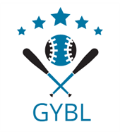Last year with your generous donations we were able to get all our team uniforms sponsored. Your sponsorship money also allowed us to provide trophies for our league and end of year tournament winners. It also helps us to keep up with the maintenance to our fields, to purchase needed equipment and to help fund our umpires.

As a board we are proud to provide the opportunity for the youth of this community not only the ability to play the game of baseball, and an environment where they can learn life lessons such as teamwork and a good sportsmanship. However, none of this is possible without your help.

We have 3 ways in which you can choose to help our program. The first is to become a Gold Sponsor which will include having your business name placed on our website and on facebook to promote your business. Our Second way is to become a Platinum Sponsor which will include having your business name on the front of the team jersey that is worn in the game by all players and coaches. Many of the players do continue to wear that shirt well after the season and will continue to help promote your business. The Third way is to be a Diamond sponsor which means you would take advantage of both opportunities for marketing your business, Team and promote your business on our website & on our facebook page.

The Greensburg Youth Baseball League truly appreciates your financial support because without that support there is no way that we could continue to offer the experiences that we have for several decades. Our 2025 season will begin with registration in January. We look forward to partnering with you to make 2025 our best year yet!

Please look over the enclosed sponsorship form and reply with your form completed and the sponsorship money. If you have any questions, please do not hesitate to contact:

Scott Noah

PH: 812-593-4357 or Brandi Noah PH: 812-593-4356 Email: [greensburgyouthbaseballleague@gmail.com](mailto:greensburgyouthbaseballleague@gmail.com)

Once again thank you for your continued support of the Greensburg Youth Baseball League