MAPLE SHADE YOUTH HOCKEY ASSOCIATION OFFICIAL RULE BOOK
2018

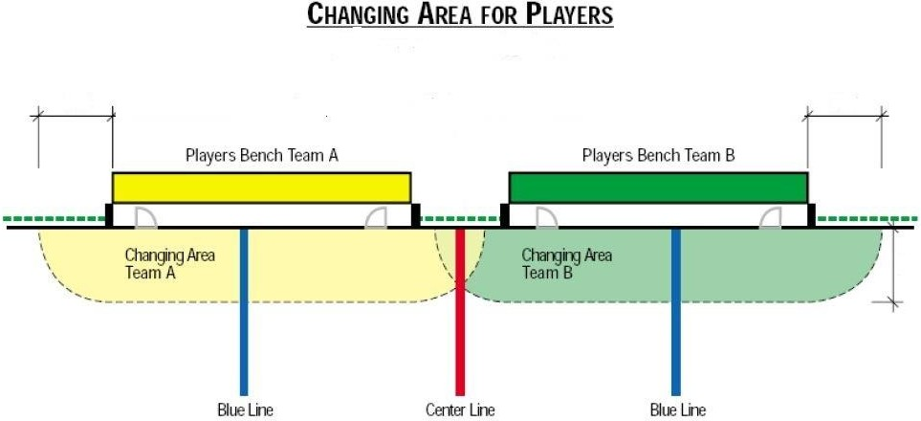

In the application of the rule, the change of one player shall constitute a line change.

SECTION 4 - PLAYING RULES
400 - PLAYERS ON THE RINK
A team shall not have more than six players on the rink at any time while the play is in progress. Bench Minor penalty for Too Many Players on the Rink (Rule 573). The six players shall be:

Goalkeeper
Right Defence Left Defence Right Wing Centre Left Wing
402 - START OF GAME AND PERIODS
The game shall begin at the scheduled time with a face-off at the center face-off spot. A face-off conducted in the same manner shall take place at the start of each period. The teams shall start the game defending the goal nearest to their player bench. Teams shall change ends for each succeeding regular or overtime period.

410 - CHANGE OF PLAYERS AND GOALKEEPERS
- Under the conditions set out in this section, the players and goalkeepers may be changed at any time
during the play or during a stoppage of play.
- If, during a substitution, the player entering the game plays the ball or makes any physical contact with an opponent while the retiring player is actually on the rink, there shall be a penalty. Bench Minor penalty for Too Many Players on the RInk (Rule 573).
- If, during the substitution, either the entering player or retiring player is struck accidentally by the ball, the play will not be stopped and no penalty called.

411 - CHANGE OF PLAYERS AND GOALKEEPERS FROM THE PLAYERS BENCH DURING PLAY
- The players and Goalkeepers may be changed at any time from the players bench while the game is in progress provided that:

  - the changing players and Goalkeepers are within an imaginary area limited by the length of the respective players bench and 10Ft from the boards, as illustrated in the above illustration,

  - the changing players and Goalkeepers are out of the play before any change is made.
Minor penalty (see Rule 573)

- If, when a goalkeeper leaves his goal crease and proceeds to his player’s bench for the purpose of substituting an other player, the substitution is made prematurely, the official will stop the play when the offending team gains possession of the ball, and the face-off will take place at the center face-off spot.

No warm-up shall be permitted for a substitute goalkeeper.

413 - CHANGE OF PLAYERS FROM THE PENALTY BENCH
A player serving a penalty, who is to be changed after the penalty has been served, must proceed at once, by way of the rink, and be at his own player’s bench before any change can be made. In case of an infraction a Bench Minor penalty (Rule 563) is assessed.

415 - CHANGE OF GOALKEEPERS DURING STOPPAGE OF PLAY
- During a stoppage of play, goalkeepers shall not be permitted to go to the players bench except to be replaced or during a time out.
In case of an infraction a Minor penalty (Rule 592) is assessed.
- When a goalkeeper substitution has been made during a stoppage of play, the goalkeeper who left the game may re-enter the game as soon as the play resumes.

416 - INJURED PLAYERS
If a player is injured and cannot continue to play or go to the bench, the play will continue until his team has secured possession of the ball, unless this team is in a scoring position.
If a player other than the goalkeeper is injured or compelled to leave the rink during the game, he may retire and be replaced by a substitute, but play must continue without the teams leaving the rink.

- If it is obvious that a player has sustained a serious injury, the referees shall stop the play immediately
- If an injured penalized player is able to return before his penalty is expired he shall go to the penalty box at the first stoppage of play.
- If an injured player received a Misconduct Penalty, no substitute is required on the penalty bench.
When play has been stopped due to an injured player, excluding the goalkeeper, the injured player shall leave the rink and may not return to the rink until after play has resumed.
If a penalized player has been injured he may proceed to the bench, and if he has been assessed a Minor, Major or Match penalty, the penalized team shall immediately put a substitute player on the penalty bench who shall serve the penalty without change, except by the injured penalized player. The injured penalized player shall not be eligible to play until his penalty has expired.

417 - INJURED GOALKEEPERS
If a goalkeeper sustains an injury or becomes ill, he must be ready to resume play immediately or be replaced by a substitute goalkeeper. If both goalkeepers of the team are incapacitated and unable to play, when possible the team shall have ten minutes to dress another player in uniform as a goalkeeper.

- When goalkeeper is injured and goes to the bench, he must be replaced.

- Referees should stop play immediately when a goalkeeper is hit in the face or head especially with a hard shot.

- If the player replacing the injured goalkeeper is dressed and ready to play before the 5 minutes is up, the remaining time may be used for a warm-up. The Referees is to check with the team whether or not the regular goalkeeper is able to return. If the team says "no", then the 5 minutes period begins.
- Once a player puts on pads and goes to the goal, the regular goalkeeper(s) may not return.

418 - PREVENTION OF INFECTIONS
A player bleeding or covered by the blood of an opposing player will be considered as an injured player and must leave the rink for treatment and/or clean-up.
Such player shall be permitted to return to the rink surface provided that:
- the cut is completely closed and sealed with appropriate bandages,
- any blood is removed from the player and his equipment and uniform are replaced or properly cleaned. If the surface, rink facilities or any objects are stained with blood, the Referees shall ensure that the blood stains are removed by rink personnel after the first stoppage of play.

420 - TIMING OF GAME
The regular game shall consist of three 12 minute actual time periods and two 3 minute intermissions. The teams shall change ends for each period.

421 - OVERTIME PERIOD
In a play-off game where a winner must be declared, the game will be prolonged by a twelve minute actual time
«sudden victory» overtime period.

In games where a winner must be declared after a three minute intermission an 12minute (sudden victory) overtime will begin:
- The sides are not changed.
- All unserved penalties continue.
- The face-off will take place at the rink center.
- The game finishes with the scoring of a goal. The team scoring the goal will be declared the winner.
- If after 12minutes a goal isn’t scored there will be a three minute intermission and an 12 minute (sudden victory) period until a goal is scored.
- If either team refuses to play overtime, the other team will be declared the winner.

«Sudden victory» means that, during the overtime period, the team who scores the first goal is declared the winner.

422 - TIME-OUT
Each team shall be permitted one 1minute time-out during the course of regular time or during overtime. During a normal stoppage of play, the Coach may ask the Referees for the time-out. The players and goalkeepers of both teams, except for penalized players, are allowed to go to their respective benches.
Each team may take their time-out at the same stoppage of play, but the team taking the second time-out must notify the Referees before the end of the first time-out.

430 - DETERMINING THE OUTCOME OF THE GAME
- The team scoring the greatest number of goals during the three12 minute periods shall be declared the winner and shall be credited with two points in the standings. If, at the end of the game, the score for both teams is equal, the game shall be declared a tie with one point credited to each team.

- In a play-off game where a winner must be declared, the game will be prolonged by a twelve minute actual time «sudden victory» overtime periods until a goal is scored.

If the game is stopped for any reason that is not specifically covered in the rules, the ball will be faced-off at the nearest face-off spot where it was last played.

FACE-OFF SPOTS
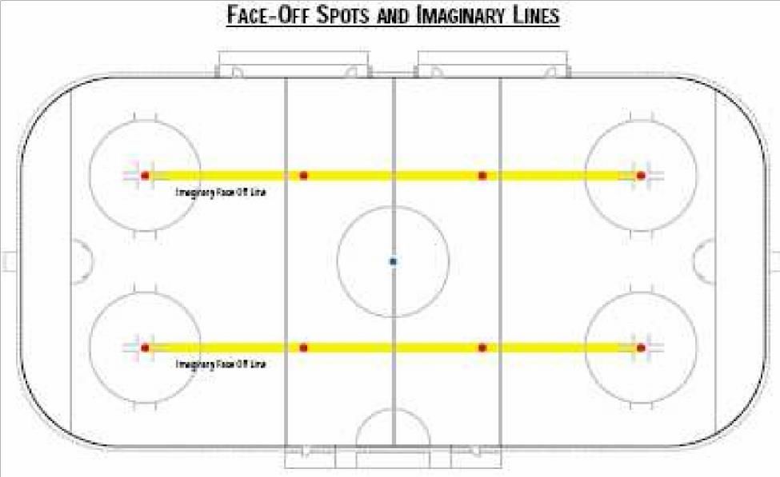
MAGINARYFACE-OFF LINE
MAGINARYFACE-OFF LINE

440 - FACE-OFFS
- A face-off shall be conducted at the beginning of each period and after any stoppage of play.
- All face-offs shall be conducted exclusively:
  - at the nine designated face-offs spots, or
- The face-offs shall be conducted at the center spot:
  - at the start of a period,
  - after a goal scored,
  - after an error of an official on flooring,
  - premature substitution of a goalkeeper.
- Face-offs shall be conducted at the end zone spots of the defending team:
  - when stoppage occurs between the end face-off spots and the near end of the rink (the ball shall be faced-off at the end face-off spot on the side where the stoppage occurred, unless otherwise expressly provided by these rules),
  - a goal illegally scored as a result of a ball deflected off an official.
  - after an attacking team does not score on a Penalty shot
- Face-offs shall be conducted at the end zone spots of the attacking team:
  - when the ball is floored by the attacking team,
  - after an intentional off-side by the attacking team,
- Face-offs shall be conducted at the neutral zone spots:
  - after an offside,
  - after any infringement of a rule made by the attacking team in his attacking zone.
- When an infringement of a rule has been committed or a stoppage of play has been caused by an attacking player in the attacking zone, the ensuing face-off shall be in the neutral zone at the nearest faceoff spot. Note: This includes a stoppage of play caused by a player of the attacking side shooting the ball on the back of the defending teams’ net without any intervening action by the defending team.
- When an infringement of any rule has been committed by players of both teams, the ensuing face-off shall be at the nearest end zone face-off spot based on the cause of the stoppage of play and not related to the location of the ball when play was stopped.
- All face-offs in the neutral zone shall be conducted at the designated face-off spots as dictated by reason for the stoppage of play. The face-off location to be used will be one of the two face-off spots nearest the offending team’s blue line in the neutral zone, thus causing a loss of territorial advantage to the offending team.
- When players of both teams cause the stoppage of play the face-off will take place at nearest neutral zone faceoff spot to where the stoppage occurred and not related to the location of the ball when play was stopped.
- For the purpose of an off-side pass: if the pass originated from the offending team’s side of center in the neutral zone the face-off will be at the face-off dot outside the offending teams blue line however if the offending team has crossed the center red line into the opposing team’s neutral zone (the area between the blue line and red line of the opposition) and an off-side pass is made from this area the face-off will take place outside the oppositions blue line at the closest face-off dot.
- When any stoppage of play in the end zone is caused by a defending player or the goaltender the ensuing faceoff shall take place the nearest end zone face-off spot based on the cause of the stoppage of play and not related to the location of the ball when play was stopped.

442 - PROCEDURE FOR CONDUCTING FACE-OFFS
- The Referees will drop the ball between the sticks of the two players (facing-off).
- The players shall be positioned squarely facing their opponent’s end of the rink, approximately one stick length apart, with the blade of their stick on the rink outside the white part of the face-off spots.

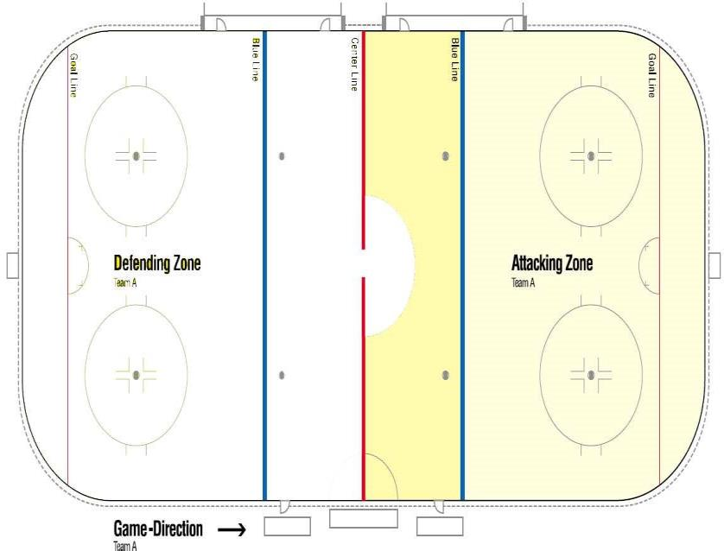
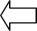
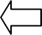
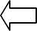
When Team A legally crosses the opponent’s blue-line with possession of the ball, the Attacking Zone expands all the way to the centerline.
FLOATING BLUE LINE
(Junior Division Only)

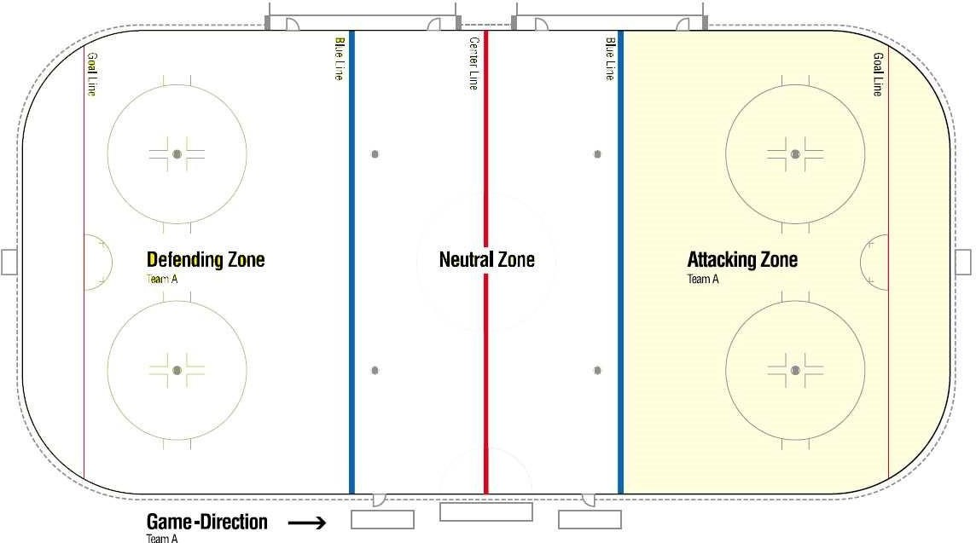
When Team B clears the ball passed the center-line, the blue-line is reset to its original position.

  - A player actually propelling and in control of the ball, who crosses the line ahead of the ball, shall not be considered offside.
  - If a defending player carries or passes the ball into his defending zone
while a player of the attacking team is in an offside position, no offside will be called.
  - An intentional offside is made for the purpose of securing a stoppage of play, regardless of the reason such as a shot on goal.

450 - OFFSIDES
Players of an attacking team may not precede the ball into their attacking zone.

The determining factors in deciding an offside are:

- the player’s shoes position - player is offside when both shoes are completely over the blue line in his attacking zone before the ball completely crosses the line,
- the ball position - the ball must have completely crossed the blue line into the attacking zone.

In violation of this rule, play shall be stopped and a face-off shall be conducted:

- at the nearest neutral zone face-off spot if the ball was carried over the blue line by the attacking player,
- at the face-off spot nearest to where the pass or shot originated when the ball was passed or shot over the blue line by an attacking player,
- at the end face-off spot in the defending zone of the offending team if, in the opinion of the Referees, a player has intentionally caused an offside.

Once the ball legally crossed the attacking blue line, then the blue line is set and the attacking zone becomes the area from the center red line in (the blue line "floats" onto the center red line). If the ball was propelled back into the neutral zone, then the blue line "returns" and encompasses the attacking zone again ("Floating Blue Line" Rule)
Interpretation: The terminology used when a team has to eliminate the blue line is "Set the blue line". The blue line is "set", when the ball is propelled entirely across the outside edge of the line, regardless if the player has moved across the line or not. The blue line remains as set until the ball is propelled across the center red line or an illegal action has been made by the attacking player, in which case the blue line returns to the initial position.

OFFSIDE PASS SITUATIONS
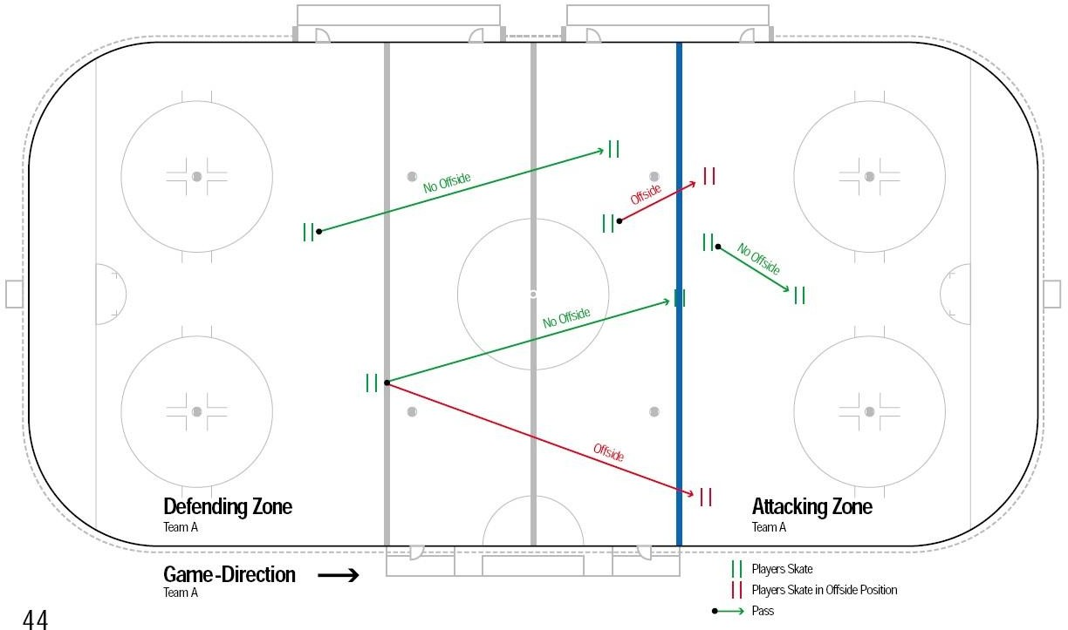

- The attacking zone must be completely clear of attacking players before the delayed offside can be nullified with the ball still in the attacking zone.
- “Immediately” means that the attacking players must not touch the ball, or attempt to gain possession of a loose ball, or force the defending ball carrier further back in the zone.
- In this second case, when the Referee drop his arm, any attacking player may re-enter his attacking zone.

- If the Referees have erred in calling an Icing, the ball shall be faced-off on the center face-off spot.
- “SHORT HANDED” means that due to a penalty(s), the team must be below the numerical strength of its opponents on the rink.

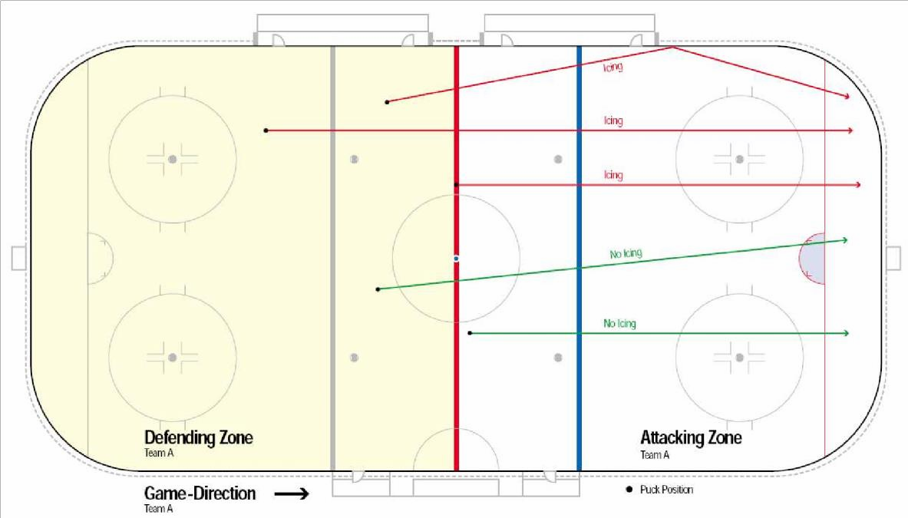
ICING THE BALL
451 - DELAYED OFFSIDE PROCEDURE
If an attacking player precedes the ball into the attacking zone, but a defending player is able to play the ball, the Referees shall raise his arm to signal by «delayed offside», except if the ball has been shot on goal causing the goalkeeper to play the ball. The Referees shall drop his arm to nullify the offside violation and allow the play to continue if:
- the defending team either passes or carries the ball into the neutral zone, or
- all attacking players immediately clear the attacking zone by making shoe contact with the blue line.

460 - ICING THE BALL
- The point of last contact with the ball by the team in possession shall be used to determine whether or not Icing has occurred.
- Should a player of a team equal or superior in numerical strength shoot, bat or deflect the ball from his own blue line (top of circles for Inst.) beyond the goal line of the opposing team, play shall be stopped and Icing shall be called.
- A face-off will take place at the end zone face-off spot of the offending team nearest to where they last touched the ball.
- No Icing will be called:
  - if the ball enters the goal - the GOAL is allowed,
  - if the offending team is short handed at the instant the ball is shot,
  - if the ball touches any part of an opposing player, including the goalkeeper, before crossing the goal line,
  - if the ball is floored directly from a player participating in a face-off,
  - if, in the opinion of the Referees, any player from the other team, except the goalkeeper, is able to play the ball before it crosses the goal line. If the offensive player clearly beats the defensive player to the top of the face off circles in the defensive zone.

  - If a defender is playing below the top of the face off circles in the defensive zone.

470 - DEFINITION OF A GOAL
A goal shall be scored:
- when the ball has been put between the goal posts below the crossbar and entirely across the goal line by the stick of a player of the attacking team,
- if the ball has been put into the goal in any way by a player of the defending team,
- if the ball has been deflected into the goal from the shot of an attacking player by striking any part of a team mate,
- if a player of the attacking team has been physically interfered by the action of any defending player so as to cause him to be in the goal crease when the ball enters the goal, unless if in the opinion of the Referees, he had sufficient time to get out of the crease,
- if the ball should become loose in the goal crease and then put into in the goal by the stick of the attacking player,
- when the ball deflects directly off the shoe of an attacking or defending player.

- No goal shall be disallowed after the face-off immediately following the scoring of that goal.
- The goal crease is defined as a volume, extending from the crease area on the rink up to the crossbar height.
- Where a goal is scored at the end of the period (11:59) and the buzzer sounds to end the period (but the goal was scored before the buzzer sounds and the Referees allows the goal to count), it is not necessary for the Referees to conduct a face-off at the center rink. In such a case, the Referees should insure that the Timekeeper records the goal at 11:59 on the Official Game Sheet. No goal may be counted if the clock is 12:00 or 0:00

- Only one point may be awarded to any one player on a goal.
- Only one assist may be awarded when a player scores after a rebound off of the goalkeeper.
- In the case of an obvious error in awarding a goal or assist, the error should be corrected promptly, but changes shall not be made once the coaches have approved the Official Game Sheet.

471 - DISALLOWING A GOAL
No goal shall be scored:
- if an attacking player deliberately kicks, throws, bats with the hands or otherwise directs the ball by any means other than his stick into the goal even if the ball has been further deflected by any player, goalkeeper or official,
- if an attacking player contacted the ball with the stick above the cross bar,
- if the ball has been directly deflected into the goal off an official,
- if an attacking player stands or holds his stick in the goal crease when the ball enters the goal, unless he has been physically interfered by the action of any defending player so as to cause him to be in the goal crease when the ball enters the goal, unless if in the opinion of the Referees, he had sufficient time to get out of the crease or unless Rule 470 applies.
- if the goal has been displaced from its normal position.
- if the goal is scored by any type of "kick shot". A "Kick shot" is made by placing the blade of the stick behind the ball and then propelling the ball by kicking the stick.

472 - GOAL AND ASSIST AWARDED TO THE PLAYER
A goal shall be credited in the scoring records to the player who propelled the ball into the opponent’s net.

When a goal has been scored, an assist shall be credited to the player(s) taking part in the play immediately preceding the action. No more than two assists can be given to any goal.

480 - BALL OUT OF BOUNDS
When the ball goes outside the playing area or strikes any obstacles, other than the boards above the rink surface, the play will be stopped and the face-off will take place at the place from where the ball was shot or deflected, unless expressly provided in these rules.

481 - BALL ON THE NET
When the ball is lodged in the outside netting of the goal for more than fifteen seconds or frozen against the goal between opposing players, the Referees shall stop the play and face-off the ball:
- at the nearest end zone face-off spot.
- at the nearest neutral zone face off-spot if, in the opinion of the Referees, the stoppage has been caused by an attacking player.

482 - BALL OUT OF SIGHT
Should a scramble take place or a player accidentally fall on the ball and the ball is out of sight of the Referees, he shall immediately stop the play, and the ball shall be faced-off at the Face-off spot nearest where the play has been stopped, unless provided for in the rules.

483 - ILLEGAL BALL
If, at any time, while play is in progress, a ball other than the one legally in play shall appear on the playing surface, the play shall not be stopped until the play then in progress is completed by change of possession.

484 - BALL STRIKING AN OFFICIAL
Play shall not be stopped because the ball touches an official except when the ball has entered the goal.

490 - STOPPING/PASSING THE BALL WITH HANDS
A player shall be permitted to stop or bat the ball in the air with the open hand or push it along the surface of the rink with his hand, unless in the opinion of the Referees, the player has deliberately directed the ball to a team-mate:
- If a team mate of such player obtains possession of the ball in the Neutral zone, play shall be stopped and the ball faced-off at the location where the offence occurred, unless the offending team gains a territorial advantage, then the face-off shall be where the stoppage of play occurred.
- If a team-mate of such a player obtains possession of the ball in his Defending zone, the Referees will not stop the play provided the hand pass is completed before the player and ball leave the zone.
- However when the ball is passed with the hand from a player in the Neutral Zone to a team mate in his
Defending Zone, the Referees will stop the play with the Face-off at point of stoppage.
- If a teammate of such player obtains possession of the ball in his Attacking Zone, the Referees will stop the play with the Face-off at the Neutral zone faceoff spot outside the Attacking zone.
- A goal shall be disallowed if the ball was batted by an attacking player even deflected into the goal by any player or his stick, goalkeeper or official into the goal.

491 - KICKING THE BALL
Kicking the ball shall be permitted in all zones, but a goal may not be scored by the kick of an attacking player unless deflected off the stick of an attacking player.

492 - HIGH STICKING THE BALL
- Stopping or batting the ball with the stick above the height of the shoulders is prohibited, the play will be stopped, unless-

a player of the defending team bats the ball in his own goal, in which case the goal is allowed.

- If the ball has been high-sticked by an attacking player in his Attacking Zone the face-off shall take place at the nearest spot in the Neutral Zone.

- If the ball has been high-sticked by a player in his Defending Zone or in the Neutral Zone face-off shall take place at the closest face off point to the place where the offence occurred unless the offending team gains a territorial advantage, then the face-off shall be at the closest face off spot to the place where the stoppage of play occurred.
- No goal can be scored when the stick of an attacking player above the height of the cross bar of the goal contacts the ball.
.

493 - INTERFERENCE BY SPECTATORS
In the event that objects are thrown on to the rink which interferes with the progress of the game, the Referees shall stop the play and the ball shall be faced-off at the spot the play was stopped.
In the event of a player being held or interfered with by a spectator, the Referees shall stop the play. If the team of the player interfered with is in possession of the ball, the play shall be allowed to be completed. Such an incident has to be reported to the Proper Authorities.

SECTION 5 - PENALTIES
500 - PENALTIES - DEFINITION AND PROCEDURES
Penalties are divided into the following categories showing time to be served:

- MINOR PENALTY (1:30)
- BENCH MINOR PENALTY (1:30)
- MAJOR PENALTY (4)
- GAME MISCONDUCT PENALTY (GM,4)
- PENALTY SHOTS (PS)

All penalties shall be actual playing time.

- Penalties imposed after the end of the game shall be reported by the Referees on the Official Game Sheet.

- Some rules state that the Coach shall designate a player to serve a penalty. If they refuse to do so, the Referees have the authority to name any player of the offending team to serve the penalty.

- When the Minor or Major penalties of two players of the same team terminate at the same time, the Referee shall designate which player shall return on the rink first.

- For all Game Misconduct the Referees shall: Report to the Proper Authorities immediately following the game.

When a player is assessed a Major and a Minor penalty at the same time, the Major penalty shall be served first. This applies when both penalties are imposed on the SAME player (see Rule 513).

- SHORT HANDED means that, due to a penalty(s), the team must be below the numerical strength of its opponents on the rink at the time the goal is scored.
- This rule also applies when a goal is scored on a Penalty Shot.

When a player is assessed a Minor or Major penalty and a Game Misconduct penalty at the same time, the penalized team shall immediately put a substitute player on the penalty bench to serve the Minor or Major penalty without change.
In this case the Game Misconduct penalty starts only after the Minor or Major penalty has been served by the substitute player.

501 - MINOR PENALTY
For a MINOR penalty, any player, other than the goalkeeper, will be ruled off the rink for 1:30 minutes and no substitution shall be permitted.

502 - BENCH MINOR PENALTY
For a BENCH MINOR PENALTY, any player, other than the goalkeeper, of the penalized team, designated by the Coach, will be ruled off the rink for 1:30 minutes and no substitution shall be permitted.

If, while a team is short handed because of one or more Minor or Bench Minor penalties,the opposing team scores a goal, the first of such penalties shall automatically terminate.

503 - MAJOR PENALTY
For a MAJOR PENALTY, any player, other than the goalkeeper, will be ruled off the rink for 4 minutes and no substitution shall be permitted.

505 – GAME MISCONDUCT PENALTY
For a GAME MISCONDUCT PENALTY, any player, including the goalkeeper or team official, will automatically be ruled to leave the facilities for the balance of the game, and any player other than the goalkeeper, of the penalized team, designated by the Coach, will be ruled off the rink for 4 minutes and no substitution shall be permitted.

- A Game Misconduct penalty does not incur automatic suspension, except for that game, but the Proper Authorities shall have the power to suspend the player or the team official from participating in further games.

- In championships and tournament games, any player or team official assessed his second Game Misconduct Penalty shall be automatically suspended for his team´s next championship or tournament game.

The player shall be ordered to leave the playing area and a substitute player shall be permitted to replace him
after four minutes playing time has elapsed.

1. A player or team official incurring a Game Misconduct shall be awarded an automatic further suspension, which means that he shall be suspended for the next game as a minimum, and his case shall be dealt with by the Proper Authorities.

– INTENT TO INJURE PENALTY
a) A GAME MISCONDUCT PENALTY (GM shall be assessed any player, including the goalkeeper or team official, who deliberately attempts to injure or deliberately injures an opponent or a referee in any manner.

For a Intent To Injure penalty, any player, including the goalkeeper, will be ruled off the rink and ordered to leave the facilities for the balance of the game and substitution shall be permitted after four minutes.

- PENALTY SHOT
Where there is an infraction of the rules that calls for a PENALTY SHOT, and if the infraction involves a Minor penalty, the non-offending team will be given the option of:
  - accepting the Penalty Shot and the penalty will not be assessed regardless of whether the Penalty Shot results in a goal or not, or
  - have a Minor penalty assessed to the offending player.

If the infraction involves any other penalty, the shot will be awarded and the penalty shall be assessed regardless of whether the Penalty Shot results in a goal or not.

- If the foul upon which the Penalty Shot is based occurred during actual playing time, the Penalty Shot will be awarded and taken immediately in the usual manner, notwithstanding any delay occasioned by a slow whistle by the Referees. In this case, the play shall be permitted to be completed, which delay results in the expiry of the regular playing time in any period.
- If the goalkeeper leaves his crease before the player has touched the ball, or commits any foul, the Referees shall raise his arm but allow the shot to be completed. If the shot fails, he shall permit the Penalty Shot to be taken again. If the goalkeeper leaves the goal crease too early, the Referees shall: issue a WARNING the first time and a new Penalty Shot, issue a Minor penalty the second time and a new Penalty Shot, award a Goal the third time,
- The goalkeeper may attempt to block the shot in any manner, except by throwing his stick or any other object, in which case a goal shall be awarded.
- When the Penalty Shot is taken, if any player of the opposing team interferes or distracts the player taking the shot, and because of such action the shot fails, the Referees shall allow a second Penalty Shot and assess a Minor penalty on the offending player.

- All penalties imposed to a goalkeeper, regardless of who serves the penalty, shall be charged in the records against the goalkeeper.

- Any additional penalties which were assessed to the goalkeeper at the same stoppage of play will apply and will be served by another player of his team who was on the rink when the penalties were assessed.

- PENALTY SHOT PROCEDURE
- The Coach of the non-offending team selects and reports to the Referees the number of any non-penalized player on the rink who shall take the shot.
- The player cannot have been assessed a delayed penalty.
- The players of both teams shall withdraw to the sides of the rink and behind the red line.
- The Referees shall place the ball on the center spot. Only a goalkeeper may defend against the Penalty Shot.
- The goalkeeper must stay in his crease until the player has touched the ball.
- The player will, on instruction of the Referees, play the ball and proceed towards his opponent’s goal line while maintaining progress towards the goal and attempt to score on the goalkeeper.
- Once the ball is shot the play shall be considered complete, and no goal can be scored by a second shot of any kind.

- If a goal is scored, the face-off will take place at center rink.
- If no goal is scored, the face-off will take place at either of the end zone face-off spots in which the Penalty Shot has been attempted.

The time required for taking a Penalty Shot will not be recorded in the actual playing time in any period.

- SUPPLEMENTARY DISCIPLINE
In addition to the suspension imposed under these rules, the proper authorities may, at any time after the conclusion of the game, investigate any incident and may assess additional suspensions for any offence committed on or off the rink at any time before during and after the game, whether or not such offences have been penalized by the Referees.

- GOALKEEPER PENALTY PROCEDURE

A goalkeeper never goes to the penalty bench

- For Minor or Major penalties assessed to the goalkeeper:
- The goalkeeper continues to play.
- His penalty will be served by another player of his team who was on the rink when the offense was committed and was designated by the Coach.

- For Game Misconduct penalties, the goalkeeper shall be ruled off the rink for the balance of the game.
He will be replaced by the substitute goalkeeper, if available, or otherwise by a member of his team, who shall be permitted 5 minutes to dress in the goalkeeper’s full equipment. The 4 minute Penalty will be served by another player of his team who was on the rink when the offense was committed and was designated by the Coach.

1. If the penalties of two players of the same team expire at the same time, the Referees will designate which of the players will return to the rink first.

PENALTY
1. When a Major and a Minor penalty are imposed at the same time on two or more players of the same team, the Scorekeeper shall record the Minor penalty as being the first of such penalties.

This also applies when the two penalties are imposed on DIFFERENT players (see Rule 501).

- COINCIDENTAL PENALTIES
When an equal number of identical penalties (Minor or Major) are assessed to both teams at the same stoppage of play, such penalties shall be known as:

COINCIDENTAL PENALTIES

When such penalties are assessed, immediate substitutions shall be made for those penalties and they shall not be taken into account for the purpose of delayed penalties. In the case where the penalized players remain in the game, they shall take their place on the penalty bench and shall not leave until the first stoppage of play following the expiry of their respective penalties.

In the application of this rule, Minor and Bench Minor penalties are considered as identical.

- DELAYED PENALTY

This rule applies only when Minor, Bench Minor, or Major penalties are involved.
- If a third player of any team is assessed a penalty while two players of his team are serving penalties, his penalty time shall not commence until the penalty time of one of the other players has elapsed.

- The player shall proceed at once to the penalty bench but may be replaced on the rink by a substitute.

- When any team has three or more players serving penalties at the same time, and because of the delayed penalty rule a substitute for the third offender is on the rink, none of the three penalized players may return to the rink until play has been stopped, unless by reason of the expiration of his penalty the penalized team is allowed to have more than four players including the goalkeeper on the rink, in which case the penalized players will be permitted to return in the order of their penalties.

- Completion of the Play by the team in possession means that the ball must have come into the possession of, and have been controlled or intentionally directed by, a player or goalkeeper of the opposing team, or has been frozen. No rebound off of any player of the opposing team, or off the goal or boards, will lead to completion of the play.
- If after the Referee has signaled a penalty, but before the whistle has been blown, the ball enters the goal of the non-offending team as the direct result of the action of the player of the non-offending team, the goal shall not be allowed, and the penalty signaled shall be imposed.

- CALLING OF PENALTIES
Should an infraction of the rules be committed which would call for a penalty:

- If the team of the offending player is in possession of the ball, the Referees shall immediately blow the whistle and assesses the penalty. The face-off shall take place at the offending teams end zone face-off spot.

- If the team of the offending player is NOT in possession of the ball, the Referee shall raise his arm, signifying the calling of a penalty and, upon completion of the play by the team in possession, will blow the whistle and assess the penalty.

- If, after the Referee has raised his arm, a goal is scored in any manner against the non-offending team, the goal will not be allowed, and a penalty shall be imposed in a normal manner.

- If, after the Referee has raised his arm, a goal is scored by the non-offending team, the goal will be allowed, and the first Minor penalty will not be assessed. All other penalties shall be assessed. If the offending team is already shorthanded, the signaled Minor penalty will be washed out, but all penalties served in the penalty bench will remain. All other penalties that occurred during the same play shall be assessed.

The face-off shall take place at the offending teams end zone face-off spot unless, during the period of a delayed whistle due to a penalty by a player of the team not in possession, the side in possession floors the ball or shoots the ball from their defensive zone so that it goes out of bounds or is unplayable.

Butt-ending identifies the act of a player who uses the shaft of the stick above the upper hand to check an opposing player.
Attempt to Butt-end shall include all cases when a butt-end gesture is made but no contact is made.

Charging identifies the act of taking more than two steps or strides to contact an opposing player.

- A player who makes physical contact with an opponent after the whistle has been blown, and if, in the opinion of the Referees, the player had sufficient time after the whistle to avoid such contact, shall be assessed, at the discretion of the Referees, a penalty for charging.
- A goalkeeper is not “Fair Game” just because he is outside of the goal crease area. A penalty for interference or charging should be called in every case where an opposing player makes unnecessary contact with a
goalkeeper.

FOULS AGAINST PLAYERS
- - BOARDING
- A player who body checks, elbows, charges or trips an opponent in such a manner that it causes the opponent to be thrown violently into the boards, shall be assessed at the discretion of the Referees, a:

Minor penalty (1:30) or
  - Major penalty + Automatic Game Misconduct penalty (4+GM)

- A player who injures his opponent as a result of boarding shall be assessed at the discretion of the Referees a:

Major penalty + Automatic Game Misconduct penalty (4+GM)

- - BUTT-ENDING
- A player who attempts to butt-end an opponent shall be assessed a:

Double Minor penalty. (1:30+1:30)

- A player who butt-ends an opponent shall be assessed a:

Major penalty + Automatic Game Misconduct penalty. (4+GM)

- A player who injures his opponent by a butt-ending shall be assessed a:

Match penalty (MP)

- - CHARGING
- A player who runs, jumps or charges an opponent or who runs, jumps or charges the opposing goalkeeper in his crease shall be assessed, at the discretion of the Referees, a:

Minor penalty (1:30) or
  - Major penalty + Automatic Game Misconduct penalty. (4+GM) or

- A player who injures his opponent as a result of charging shall be assessed, at the discretion of the Referees, a:

Major penalty + Automatic Game Misconduct penalty. (4+GM)

- A check from behind is a check delivered on a player who is not aware of the impending hit, is unable to protect himself and contact is made on the back part of the body.
- However, if a player intentionally turns his body to create contact, this would not be classified as check from behind.
- “Clipping” is the act of throwing the body across or below the knee of an opponent, charging, or falling into the knees of an opponent after approaching him from behind, side or front.

- CHECKING FROM BEHIND
- A player who runs, jumps, charges or hits in any manner an opponent from behind shall be assessed, at the discretion of the Referees, a

Minor penalty (1:30)

- A player who injures an opponent as result of checking from behind shall be assessed, a
:

Major penalty + Automatic Game Misconduct penalty (4+GM)
- - CLIPPING
- A player who delivers a check in a clipping manner or lowers his own body position to deliver a check on or below an opponent’s knees, shall be assessed a:

Minor penalty (1:30) or
  - Major penalty + Automatic Game Misconduct penalty (4+GM)

- A player who injures his opponent by a clipping action, shall be assessed a:

Major penalty + Automatic Game Misconduct penalty (4+GM)
- - CROSS-CHECKING

A crosscheck is a check delivered with both hands on the stick and no part of the stick on the rink.
- A player who cross-checks an opponent shall be assessed, at the discretion of the Referees, a:

Minor penalty (1:30) or
  - Major penalty + Automatic Game Misconduct penalty (4+GM)

- A player who injures an opponent by cross-checking shall be assessed a:

Major penalty + Automatic Game Misconduct penalty (4+GM)

For the application of this rule, if one player is on the rink and one is off the rink, both shall be considered on the rink.

- ELBOWING
- A player who uses his elbow to foul an opponent shall be assessed a:

Minor penalty (1:30) or
  - Major penalty + Automatic Game Misconduct penalty (4+GM)

- A player who injures an opponent by elbowing shall be assessed a:

Major penalty + Automatic Game Misconduct penalty (4+GM)

- - EXCESSIVE ROUGHNESS
Any player who commits an action not permitted by the rules that may cause or causes an injury to an opponent, to a team or game official shall be assessed a:

MAJOR penalty (4)

- - FISTICUFFS OR ROUGHING
- A player who intentionally takes off his glove/s in a fight or altercation shall be assessed a:

Game Misconduct penalty (4+GM)

- A player who starts fisticuffs shall be assessed a:

Game Misconduct penalty (4+GM)

- A player who, having been struck, retaliates with a blow or attempted blow, shall be assessed a:

Game Misconduct penalty (4+GM)

- Any player or goalkeeper who is the first to intervene in an altercation already in progress, shall be assessed a:

Game Misconduct penalty (4+GM)

- - HEAD-BUTTING
A player who attempts or deliberately head-butts an opponent shall be assessed a:

Game Misconduct penalty (4+GM)

- - HIGH STICKING
- Carrying sticks above the normal height of the shoulders is prohibited and any player violating this rule shall be assessed a:

Minor penalty (1:30)

- A player who carries or holds any part of his stick above the height of the shoulders and causes an injury with the stick to an opposing player shall be assessed a:

Major penalty + Automatic Game Misconduct penalty (4+GM)

- However, if the high sticking action that caused the injury was judged accidental, the offending player shall be assessed a:

Double Minor penalty (1:30+1:30)

- - HOLDING AN OPPONENT
A player who holds an opponent with his hands or stick shall be assessed a:

Minor penalty (1:30)

- - HOLDING THE STICK
A players who holds an opponent’s stick with his hands or in any other way shall be assessed a:

Minor penalty (1:30)

BREAKAWAY

- Control of the ball is the act of propelling the ball with the stick. If the ball is touched by another player or his equipment while it is being propelled and hits the goal or goes free, the player shall no longer be considered to be in control of the ball.

- A Breakaway can be defined as a situation when a player is in full control of the ball and has no opposing player between himself and the opposing goalkeeper or goal, if the goalkeeper has been removed.

- The Referees shall not stop the play until the attacking team has lost possession of the ball.

- The position of the ball shall be the determining factor. The ball must be fully outside the defending zone, which can be the red line or the blue line depending on the fact, whether the blue line has "jumped" on the red line or not to award a Penalty Shot or a goal.

- The intention of this rule is to restore a reasonable scoring opportunity which may have been lost by reason of a foul from behind.

  - This rule applies to any interference action, such as:
    - knocking a stick out of an opponent's hands,
    - preventing a player who lost his stick to regain possession,
    - kicking or shooting any abandoned or broken stick or any object towards an opposing ball carrier.

  - The last player to touch the ball, other than a goalkeeper, shall be considered as in possession of the ball.

  - If an attacking player deliberately stands in the goal crease, without interfering with the goalkeeper, the Referees shall stop the play and the ensuing face-off shall take place at the nearest face-off spot in the neutral zone.

- HOOKING
- A player who impedes or seeks to impede the progress of an opponent by hooking him with his stick shall be assessed a:

Minor penalty (1:30) or
  - Major penalty + Automatic Game Misconduct penalty (4+GM)

- A player who injures an opponent by hooking shall be assessed at the discretion of the Referees:

Major penalty + Automatic Game Misconduct penalty (4+GM)

- In a breakaway situation, when a player in control of the ball outside his own defending zone has no opponent to pass to other than the goalkeeper and he is hooked from behind, thus preventing a reasonable opportunity to score, he will be awarded a:

Penalty Shot

- If, when the opposing goalkeeper has been removed from the rink, and the player in control of the ball outside of his own defending zone is hooked, with no opposition between him and the opposing goal, thus preventing a reasonable opportunity to score, the Referees will immediately stop the play and shall award a:

Goal

- - INTERFERENCE
- A player who interferes or impedes the progress of an opponent who is not in possession of the ball shall be assessed a:

Minor penalty (1:30)

- A player on either the players bench or the penalty bench who, by means of his stick or his body, interferes with the movement of the ball of any opponent on the rink during the progress of the play, shall be assessed a:

Minor penalty (1:30)

- A player who, by means of his stick or his body, interferes with or impedes the progress of the goalkeeper while he is in his goal crease, shall be assessed a:

Minor penalty (1:30)

- If, when the goalkeeper has been removed from the rink, any member of his team, including a team official not legally on the rink, interferes by means of his stick or his body with the movement of the ball of an opposing player, the Referees shall award to the non-offending team a: - Goal

- The Referees should award a slashing penalty to any player who swings his stick at an opponent without actually striking him, or makes a wild swing at the ball with the object of intimidating an opponent.

- Tapping the stick of the ball carrier is not considered slashing if it is limited to hitting the stick for the sole purpose of taking the ball.

- KICKING
A player who kicks or attempts to kick another player, shall be assessed a:

- Game Misconduct penalty (4+GM)

- - KNEEING
- A player who uses his knee to foul an opponent shall be assessed a:

Minor penalty (1:30) or
  - Major penalty + Automatic Game Misconduct penalty (4+GM)

- A player who injures an opponent by kneeing shall be assessed a:

Major penalty + Automatic Game Misconduct penalty (4+GM)

- - SLASHING
- A player who impedes or seeks to impede the progress of an opponent by slashing with his stick shall be assessed, at the discretion of the Referees, a:

Minor penalty (1:30) or
  - Major penalty + Automatic Game Misconduct penalty (4+GM)

- A player who injures an opponent by slashing shall be assessed a:

Major penalty + Automatic Game Misconduct penalty (4+GM)

- A player who swings his stick at another player in the course of any altercation shall be assessed a:

Major penalty + Automatic Game Misconduct penalty (4+GM)

- “Attempt to spear” shall include all cases when a spearing gesture is made but no contact is made.

- Spearing is the action of stabbing an opponent with the point of the stick blade, whether or not the stick is being carried with one or both hands.

Important: If, in the opinion of the Referees, a player is unquestionably hook checking the ball such a manner that it shall cause his opponent to trip or fall and obtains possession of it, thereby tripping the ball carrier, no penalty will be imposed.

- A breakaway can be defined as a situation where a player is in full control of the ball and has no opposing player between himself and the opposing goalkeeper or goal, if the goalkeeper has been removed.

- Control of the ball is the act of propelling the ball with the stick. If the ball is touched by another player or his equipment while it is being propelled, or hits the goal or goes free, the player shall no be longer considered as being in control of the ball.

- The Referees shall not stop the play until the attacking team has lost possession of the ball.

- The position of the ball shall be the determining factor. The ball must be fully outside the defending blue line respectively red line to award a Penalty Shot or a goal.

- The intention of this rule is to restore a reasonable scoring opportunity which has been lost by reason of a foul from behind.

- SPEARING
- A player who attempts to spear an opponent shall be assessed a:

Major penalty + Automatic Game Misconduct penalty (4+GM)

- A player who spears an opponent shall be assessed a:

Major penalty + Automatic Game Misconduct penalty (4+GM)

- A player who injures an opponent by spearing shall be assessed a:

Major penalty + Automatic Game Misconduct penalty (4+GM)
- - TRIPPING
- A player who shall place his stick, leg, foot, arm, hand or elbow in such a manner that it shall cause his opponent to trip or fall shall be assessed, at the discretion of the Referees, a:

Minor penalty (1:30) or
  - Major penalty + Automatic Game Misconduct penalty (4+GM)

- A player who injures an opponent by tripping shall be assessed a:

Major penalty + Automatic Game Misconduct penalty (4+GM)

- A Minor penalty (1:30) or, at the discretion of the Referee, a Major penalty + Automatic Game Misconduct penalty (4+GM) shall be assessed any player who uses his feet to knock an opponent’s feet out from under him with a kicking or leg dragging motion from behind (“slew footing”).

Note: If a player in the process of falling or sliding along the floor, hits or knocks the ball from his opponent’s stick prior to making actual body contact, the tripping shall be called.

- In a breakaway situation, when a player, in control of the ball outside his own defending zone with no opponent to pass to other than the goalkeeper, is tripped from behind, thus preventing a reasonable scoring opportunity, his team will be awarded a:

Penalty Shot

- If, when the opposing goalkeeper has been removed from the rink, and the player in control of the ball outside his own defending zone, with no opponent between him and the opposing goal is tripped from behind, his team shall be awarded a:

- Goal
A Minor Penalty shall be inflicted were the physical impact of the player body checking his opponent is considered not to be violent physical impact, the Referee may inflict a Major penalty + Automatic Game Misconduct Penalty especially if the body check is executed in a way, that is considered to be violent physical impact.

– CHECKING TO THE HEAD AND NECK AREA
- A player who directs a check or blow, with any part of his body, to the head and neck area of an opposing player or ”drives” or ”forces” the head of an opposing player, shall be assessed a:

- Major penalty + Automatic Game Misconduct penalty (4+GM)

- A player who injures an opponent as result of checking to the Head and Neck Area shall be assessed, a

Major penalty + Automatic Game Misconduct penalty (4+GM)
Blows to the head area during a fight or altercation are covered and are to be penalized under rule 528 Fisticuffs or Roughing.

– BODY CHECKING
A Minor penalty or, at the discretion of the Referee, a Major penalty + Automatic Game Misconduct penalty (4+GM) shall be Assessed any player who, in the opinion of the Referee, intentionally body checks, bumps, shoves or pushes any opposing player. If a player is injured, a Major penalty + Automatic Game Misconduct penalty (4+GM) must be assessed.

When the offensive player is running towards the defensive player, the defending player may not hit the offensive player by going in the opposite direction to that player. The body contact must be as a result of the movement of the offensive player. There must be no action where the offensive player is pushed, checked or shoved into the boards. Where, in the opinion of the Referee, accidental contact has taken place, no penalty shall be assessed.

1. To enforce this rule, the Referees has, in many instances, the following options:

- Bench Minor penalty for violations occurring on or in the vicinity of the players bench, but off of the playing surface and affecting non-playing personnel.

- Misconduct penalty for violations occurring on the playing surface or in the penalty bench and where the penalized player is readily identifiable.

OTHER PENALTIES
550 – ABUSE OF OFFICIAL AND UNSPORTSMANLIKE CONDUCT BY PLAYERS
- A player who dives in an attempt to have his opponent assessed a penalty shall be assessed a:

- Minor penalty (1:30)

- If any player,
  - when penalized, does not go directly to the penalty bench or the dressing room,
  - while off the rink, uses obscene, profane or abusive language or to any official, or any person or
  - while off the rink, interferes in any manner with any official, his team shall be assessed a:

Bench Minor penalty (1:30)

- A player who,
  - - challenges or disputes the ruling of any official during the game
  - - shoots intentionally the ball out of reach of an official who is retrieving it, shall be assessed a:

Major penalty (4)

For any further dispute, he shall be assessed a:

Game Misconduct penalty (4+GM)
-

- The player’s gloves and stick shall be delivered to him at the penalty bench by a team mate.If a player on the rink,
  - uses obscene, profane or abusive language or makes any obscene gesture to any person on the rink or anywhere in the rink before, during or after the game except in the vicinity of the bench,
  - bangs the boards with a stick or other object at any time,
  - fails to go directly and immediately to the penalty bench following a fight or any altercation which he has been involved or causes any delay retrieving his equipment,
  - persists to incite an opponent into occurring a penalty, or deliberately throws any stick or equipment out of the playing area, he shall be assessed a:

Major penalty (4)

- A player who uses or makes any racial remark or ethnic slur shall be assessed a:

- Game Misconduct penalty (4+GM)

- Any player who
  - intentionally touches with hands or stick, holds or pushes or checks with hands, stick or body, trips, slashes, hits in any manner or spits at a game official, or
  - makes a travesty of or interferes with or is detrimental to the conducting of the game, or -
spits to any person on the rink or anywhere in the rink, shall be assessed, a:

- Game Misconduct penalty (4+MP)

551 - ABUSE OF OFFICIALS AND UNSPORTSMANLIKE CONDUCT BY TEAM OFFICIALS
- If any team official:
  - uses obscene, profane or abusive language or makes any obscene gesture to any official or any person, or
  - interferes in any manner with any of the officials of the game, or - bangs the boards with a stick or other object at any time, his team shall be assessed a:

Bench Minor penalty (1:30)

- If he persists, or if he is guilty of any type of misconduct he shall be assessed a:

- Game Misconduct penalty (4+GM)

- A team official who uses or makes any racial remark or ethnic slur shall be assessed a:

- Game Misconduct penalty (4+GM)

- If any team official,
- holds or strikes an official, or spits at a game official, he shall be assessed a:

Game Misconduct penalty (4+GM)

- - DELAYING THE GAME

554a) - KEEPING THE BALL IN MOTION
- The ball must be kept in motion at all times. A team in possession of the ball in its own defending zone shall advance the ball towards the opposing goal except:
  - to carry the ball behind his goal once,
  - if it is prevented to do so by players of the opposing team, or - if the team is shorthanded.

-

A player beyond his defending zone shall not pass or carry the ball backward into his defending zone for the purpose of delaying the game, except when his team is shorthanded. For the first infraction, the Referees shall assess a:

Warning

For the second infraction, during the same period, the offending player shall be assessed a:

Minor penalty (1:30)

- Any player or goalkeeper who holds, freezes, or plays the ball with his stick, runs or body along the boards in such a manner to cause a stoppage of play, unless he is actually checked by an opponent, shall be assessed a:

Minor penalty (1:30)

554b) - DISPLACING THE GOAL
- A player or goalkeeper who deliberately displaces a goal post from its normal position shall be assessed a:

Minor penalty (1:30)

- If it happens during the last two minutes of the game, or at any time in overtime, by a defending player or goalkeeper in his defending zone the Referees shall award to the non-offending team a:

Penalty Shot

- If a player or goalkeeper deliberately displaces a goal post from its normal position when an opponent is in control of the ball with no opposition between him and the goalkeeper, and with a reasonable opportunity to score, the Referees shall award to the nonoffending team a:

Penalty Shot

- If, when the opposing goalkeeper has been removed from the rink, a player of his team displaces a goal post from its normal position the Referees will award to the non offending team a:

Goal

554c) - SHOOTING OR THROWING THE BALL OUTSIDE THE PLAYING AREA
A player who deliberately shoots the ball outside the playing area, or a goalkeeper who shoots the ball directly outside the playing area, or a player or goalkeeper who throws or deliberately bats the ball with his hand or stick outside the playing area, shall be assessed a:

Minor penalty (1:30)

554d) - ADJUSTMENT OF EQUIPMENT
Play shall not be stopped, nor the game delayed by reason of repair or adjustments to players equipment and uniform, and the player requiring such adjustments shall retire from the rink.

Play shall not be stopped, nor the game delayed by reason of repair or adjustments to goalkeepers equipment and uniform, and the goalkeeper requiring such adjustments shall retire from the rink and the substitute goalkeeper shall take his place immediately. For any infraction to this rule the player or goalkeeper shall be assessed a:

Minor penalty (1:30)

554e) - INJURED PLAYER REFUSING TO LEAVE THE RINK
An injured player who refuses to leave the rink shall be assessed a:

Minor penalty (1:30)

554f) - MORE THAN ONE CHANGE AFTER GOAL SCORED
If a team after scoring a goal has more than one change of players on the rink it shall be assessed a:

Bench Minor penalty (1:30)

554g) - VIOLATION OF FACE-OFF PROCEDURES
- When a player has been removed from the face-off by an official and another player of the same team delays taking up his proper position after a WARNING, the team shall be assessed a:

Bench Minor penalty (1:30)

- When a player not taking the face-off enters the face-off circle before the ball is dropped, the player on his team taking the face-off shall be removed and replaced. For the second violation during the same face-off, the offending player shall be assessed a:

Minor penalty (1:30)

- - ILLEGAL OR DANGEROUS EQUIPMENT
- A player or goalkeeper who,

  - wears his equipment or visor in a way that may cause an injury to an opponent, or
  - wears any non-approved equipment,
  - uses or wears illegal or dangerous shoes, sticks or equipment
  - A player who wears a glove in play from which all or part of the palm has been removed or cut to permit the use of bare hand.

The guilty player shall not be allowed to participate in the game until the illegal equipment has been corrected or removed.

A WARNING shall be issued to his team.

For a second violation by any player of the same team for any offence, the Referees shall assess a:

o Major penalty (4)

to the offending player.

- A player on the rink whose helmet comes off during play , who does not put the helmet back on with chin strap properly fastened, or does not return to his bench, and continues to play shall be assessed a :

- Minor penalty (1:30)

- A broken stick is one which, in the opinion of the Referees, is unfit for normal play.

- A player without a stick may participate in the game.

A player who drops on the rink to block a shot should not be penalized if the ball is shot under him or becomes lodged in his clothing or equipment, but any use of the hands to make the ball unplayable will be penalized.

- BROKEN STICK
- A player or goalkeeper whose stick is broken may not receive a stick thrown onto the rink, but may receive a stick from a team-mate without proceeding to his player bench.

- If a player whose stick is broken does not immediately drop the broken portions, he shall be assessed a: - Minor penalty (1:30)

- A goalkeeper may continue to play with a broken stick until the next stoppage of play or until he has been legally provided with a new stick.

- If an identified player throws a new stick to a goalkeeper from the players bench, the player shall be assessed a:

Minor penalty (1:30)

- If a team official throws the new stick to him from the players bench his team shall be assessed a:

Bench Minor penalty (1:30)

- If the stick is thrown by an unidentified person in the vicinity of the players bench, the team shall be assessed a:

Bench Minor Penalty (1:30)

- If the goalkeeper goes to the bench during a stoppage of play to replace his stick, he shall be assessed a: -

. - Minor penalty (1:30)

However, the goalkeeper is allowed to go to the bench and change his stick when the play is in progress.

- If a player participates in the play while taking a replacement stick to a player or goalkeeper, he shall be assessed a:

Minor penalty (1:30)

- - FALLING ON THE BALL BY A PLAYER
- If a player, other than the goalkeeper, who deliberately falls on, holds or gathers the ball into his body, he shall be assessed a:

Minor penalty (1:30)

- If a defending player, other than the goalkeeper, deliberately falls on, holds or gathers the ball into his body or the goalies body when the ball is in the goal crease of his team, the Referees will award to the non- offending team a:

Penalty Shot
- If the opposing goalkeeper has been removed from the rink and a player deliberately falls on, holds or gathers the ball into his body when the ball is in the goal crease of his team, the Referees will award to the non-offending team a:

- - Goal

557A - FALLING ON THE BALL BY A GOALKEEPER
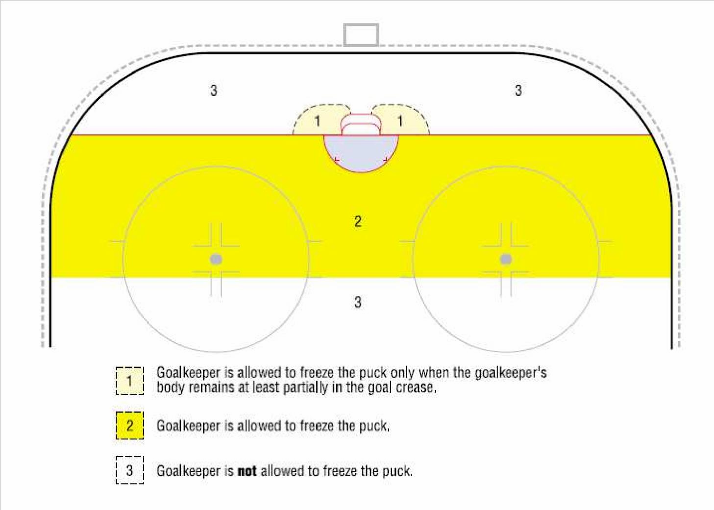

- A player is permitted to stop, bat or push the ball along the rink with his hands. However, NO GOAL can be allowed if the ball was batted by an attacking player with the hand, even if it deflects off of a player of either team or official.
- The object of this rule is to keep the ball in play continuously and any action by the goalkeeper which causes an unnecessary stoppage of play shall be penalized.

- FALLING ON THE BALL BY A GOALKEEPER
If a goalkeeper, whose body is entirely outside the goal crease, and when the ball is behind the goal line or beyond the half circle, deliberately falls on or gathers the ball into his body, or holds or places the ball against any part of the goal or the boards, he shall be assessed a:

Minor Penalty (1:30)
- - HANDLING THE BALL WITH HANDS BY A PLAYER
- Any player, except the goalkeeper, who closes his hand on the ball or picks up the ball from the rink with hands shall be assessed a:

Minor Penalty (1:30)

- If any player, except the goalkeeper, picks up the ball with his hands from the rink in the goal crease, the Referees shall award to the non-offending team a:

Penalty Shot

- - HANDLING THE BALL WITH HANDS BY A GOALKEEPER
- Unless he is being pressured a goalkeeper who holds the ball more than five seconds shall be assessed a:

Minor penalty (1:30)

- A goalkeeper who deliberately drops the ball into his pads shall be assessed a:

Minor penalty (1:30)

- - INTERFERENCE WITH SPECTATORS
A player who physically interferes with a spectator shall be assessed, at the discretion of the Referees, a:

Game Misconduct penalty (4+GM)

- If a player shall illegally enter the game from his own player’s bench or from the penalty bench by his own error or the error of the Penalty Bench Attendant, any goal scored by his own team shall be disallowed, while he is illegally on the rink, but all penalties imposed to both team shall be served.

- If the player leaves the penalty bench because of an error of the Penalty Bench Attendant, he shall not be penalized but shall serve the remaining amount of time of his penalty when he re-entered the game.

- The Penalty Bench Attendant shall note the time and advise the Referees at the first stoppage of play.

- Substitutions made prior to the altercation shall be permitted provided the players so substituting do not enter the altercation.

- If players of both teams leave their respective benches at the same time, the first identifiable player of each team will be penalized under this rule.

- For the purpose of determining which player was the first to leave his players bench, the Referees may consult off-rink officials.

- A maximum of five Misconduct and/or Game Misconduct penalties per team can be assessed under this rule.

- PLAYERS LEAVING THE PENALTY OR PLAYERS BENCH
- Any player, other than as specified in Rule 564 below, who leaves the penalty bench or players bench and incurs a Minor, Major or Misconduct penalty for his actions, shall be automatically assessed a:

Game Misconduct penalty (4+GM)

- If a player illegally enters the game and interferes with a player of the opposing team possession of the ball, who has no opponent between him and the goalkeeper, the Referees shall award a:

Penalty Shot

- If, when the opposing goalkeeper has been removed from the rink, a player illegally enters the game and interferes with a player of the opposing team in possession of the ball, the Referees shall award a:

Goal

- - PLAYERS LEAVING THE PENALTY BENCH
Except at the end of a period, a penalized player who leaves the penalty bench before his penalty time has expired shall be assessed a:

Minor penalty (1:30)

If the violation occurs during a stoppage of play during an altercation, the offending player shall be assessed a:

Game Misconduct penalty (4+GM)

to be served at the expiration of his previous penalty.

If a player serving a penalty on the penalty bench is to be changed after the penalty has been served, and does not proceed at once by way of the rink to his own players bench before any change is made, his team shall be assessed a:

Bench Minor penalty (1:30)

- - PLAYERS LEAVING THE BENCHES DURING AN ALTERCATION
No player may leave the players or penalty bench at any time during an altercation. The first player to leave the players or penalty bench during an altercation shall be assessed a:

Game Misconduct penalty (4+GM)

Any other player or players who leave the players or penalty bench during an altercation shall be assessed a:

Major penalty (4)

All forfeit decision made by any referee is only provisional. The proper authority has to review all such decisions before they become definitive.

- TEAM OFFICIALS LEAVING THE PLAYERS BENCH
Any team official who goes on the rink during any period without the permission of the Referees shall be assessed a:

Game Misconduct penalty (GM+4)

- - REFUSING TO START PLAY - TEAM ON THE RINK
If, when both teams are on the rink and one team refuses to play for any reason when ordered to do so by the Referees, the Referees shall warn the Coach and allow to the team so refusing 30 seconds to begin the game or resume play.

If, at the end of that time the team still refuse to play, the Referees shall assess a:

Bench Minor penalty (1:30)

If there be a recurrence of the same incident, the Referees will declare the game forfeited to the non-offending team and the case shall be reported to the proper Authorities for further actions.

- REFUSING TO START PLAY - TEAM NOT ON THE RINK
If a team, which is not on the rink, fails to go on the rink to start playing when ordered by the Referees, the Referees will allow to the refusing team one minute.

If the team resumes play within the minute, it shall be assessed a:

Bench Minor penalty (1:30)

If, at the end of that time the team still fails to go on the rink, the Referees will declare the game forfeited to the non-offending team.

- THROWING A STICK OR ANY OBJECT OUT OF THE PLAYING AREA
Any player or goalkeeper who throws a stick or part of it out of the playing area shall be assessed, at the discretion of the Referees, a:

Major penalty (4)

1. When a player or goalkeeper discards the broken portion of a stick by tossing it to the side of the rink (and not over the boards) in such a way not to interfere with play or opposing player, no penalty will be imposed for so doing.

The position of the ball shall be the determining factor in this instance. The ball must be fully outside of the defending zone blue line in order to award a Penalty Shot or a goal.

- THROWING A STICK OR ANY OBJECT WITHIN THE PLAYING AREA
Any player or goalkeeper on the rink who throws his stick or any part of it or any other object in the direction of the ball in his attacking zone or in the neutral zone shall be assessed a:

Major penalty (4)

If any player, goalkeeper or team official of the defending team on the rink throws his stick or any part of it or any other object in the direction of the ball in his defending zone, his team shall be assessed a:

Penalty Shot

If the goalkeeper intentionally leaves his stick or any part of it or any other object in front of his goal, and if the ball hits such objects while the goalkeeper is on or off the rink, the Referees shall award to the non-offending team a:

Goal

- - THROWING A STICK OR ANY OBJECT ON A BREAKAWAY SITUATION
When a player in control of the ball outside his own defending zone, and having no opponent to pass to other than the goalkeeper, is interfered with a stick or any object thrown or shot by any member, including team officials of the defending team, the Referees shall award to the non-offending team a:

Penalty Shot

If, when the opposing goalkeeper has been removed and a player of that team on the rink throws his stick or any part of it or any other object in the direction of the ball thereby preventing a shot on the empty net, the Referees shall award to the non-offending team a
:

Goal

- - PREVENTION OF INFECTIONS BY BLOOD
A player bleeding or covered by blood of an opponent player will be considered as an injured player and must leave the rink for treatment and/or cleaning. If he does not comply with this regulation he shall be assessed a:

Minor penalty (1:30)

573 - TOO MANY PLAYERS ON THE RINK
If, at any time during play a team has more than the number of players on the rink to which they are entitled, the team shall be assessed a:

- Bench Minor penalty (1:30)

If, in the last two minutes of the game and at any time in overtime a deliberate illegal substitution (too many players on the rink) is made, the Referees shall award to the non-offending team a:

- Penalty Shot

590 - PENALTIES FOR GOALKEEPERS
The procedures for goalkeeper penalties are outlined in Rule 511.

Specific penalties for goalkeepers are outlined in the following rules:
- 509 Penalty Shot Procedure
- 554c Shooting or Throwing the Ball Outside the Playing Area
- 556 Broken Stick
- 558 Falling on the Ball
- 560 Handling the Ball with Hands
- 568 to 570 Throwing a Stick or Any Object

591 - GOALKEEPER BEYOND THE CENTER RED LINE
If a goalkeeper participates in the play in any manner when he is beyond the center red line, he shall be assessed a:

- Minor penalty (1:30)

592 - GOALKEEPER GOING TO THE PLAYERS BENCH DURING STOPPAGE OF PLAY
If a goalkeeper goes to the players bench during a stoppage of play, except to be replaced or during a time out, he shall be assessed a:

- Minor penalty (1:30)

593 - GOALKEEPER LEAVING HIS CREASE DURING AN ALTERCATION
If a goalkeeper leaves the immediate vicinity of his crease during an altercation he shall be assessed a:

- Minor penalty (1:30)

594 - GOALKEEPER DROPPING THE BALL ON THE GOAL NETTING
If a goalkeeper drops the ball on the goal netting to cause a stoppage of play he shall be assessed a:

- Minor penalty (1:30)

650 - WEARING FULL FACE MASKS
Players and goalkeepers must wear a full face mask which meets approved HECC standards. The full face masks must be constructed in such a way that neither the ball nor a stick blade/shaft might get through it.

- During the warm-up:
  - each team shall confine their activities to their own defensive zone, so as to leave clear the neutral zone,
  - all players must wear their complete equipment.

A4.1 - INCAPACITATED REFEREES - BEFORE THE GAME
If, for any reason, the appointed Referees are prevented from appearing, the team coaches shall agree on replacement Referees. If they are unable to agree, the Proper Authorities shall appoint the officials.

A4.2 - INCAPACITATED REFEREES - DURING THE GAME
If a Referee leaves the rink or is injured, the other Referees shall stop the play, unless one team has a scoring opportunity. If the Referees is unable to continue to officiate, the other Referee shall have the power to appoint a replacement if he deems it necessary.
If the appointed official is able to return during the progress of the game, he shall replace the temporary official at once.

A4.8 - TWO OFFICIAL SYSTEM
The Referees will have general supervision of the game and their decision shall be final in case of any dispute on the rink.

ANNEX 5 REFEREE PROCEDURE TO SIGNAL AND CALL A PENALTY

- To signal a penalty, the Referee will put his arm up, but it is not necessary to point to the offending player while play is in progress.

- On the delayed calling of a penalty, the back Referee has the responsibility for watching the exchange of players if a team substitutes for the goalkeeper.

- After stopping play, the Referee indicates to a player by calling out his number, team color.

- At no times should the Referees take his eyes off the penalized player with the most crucial time being immediately following the stoppage of play.

ANNEX 6 COINCIDENTAL MAJOR PENALTIES
When canceling coincident Major/Match penalties the following procedure will be used in the order listed - “MOTO”:
- Cancel as Many penalties as possible.
- Cancel in a way to make the team only One player short.
- Cancel in a way to avoid Taking an extra player off the floor.
- Cancel using the order of penalty Occurrence or in the order that they were reported by the Referee.

SITUATION 1
A6 - 4+GM B12 - 4+GM A7 - 4+GM
Team A to resume play 1 player short.A7 to serve the time penalty to be served by player from on the floor. A6 penalty is cancelled due to order of occurrence.

A6 - 4+GM+4+GM B12 - 4+GM
Team A will play 1 player short for 4 minutes. Team A must take a player from the floor to serve the time penalty.

A6 - 4+GM+1:30 B8 – 1:30 + 1:30 A7 - 4+GM+1:30 B9 - 4+GM+4+GM
Immediate Substitution - Full Strength.

SITUATION 2
A3 – 1:30 B7 – 1:30 A4 – 1:30 B8 - 4+GM A6 - 4+GM
Team A will resume play 1 player short for 1:30 minutes. A4 will serve the time penalty because of order of occurrence.

SITUATION 3
A3 - 4+GM+ 1:30 B7 – 1:30
A4 - 4+GM+1:30+1:30 B8 - 4+GM+ 1:30
A6 - 4+GM B9 - 4+GM+4+GM+ 1:30
Immediate Substitution - Full Strength.

SITUATION 4
A player involved in the coincidental penalty rule must serve the full amount of time assessed to him, except if a goal scored against his team washes out a portion of a Minor penalty.
A9 - 4+GM+ 1:30 B14 - 4+GM @8:40
B Scores @8:25
The coincidental penalty rule is applied and immediate substitution is permitted for B14.
Team A is required to send a player from the floor to the penalty bench to serve the time penalty assessed to A9. The time penalty starts at 8:40. With the goal by Team B at 8:25, the time penalty being served is washed out.

SITUATION 5
A6 - 4+GM + 1:30 B11 - 4+GM A7 - 4+GM
Team A will play 1 player short for 5:30 minutes. A7 will cancel with B11 to place Team A only 1 player short.

SITUATION 6
A6 – 1:30+1:30 B11 - 4+GM+1:30 A7 - 4+GM+ 1:30 B12 - 4+GM+4+GM A8 - 4+GM
Team A and B will each resume play 1 player short. A6 will serve the 3 minute time penalty. Team B will need a player from the floor to serve the 4 minute time penalty to B12.

SITUATION 7
A6 - 4+GM+2 B11 - 4+GM+4+GM+1:30+1:30 A7 - 4+GM B12 - 4+GM+4+GM
A8 - 4+GM
Team B will start 1 player short. Team B will need a player from the floor to serve the 5:30 minute time penalty to B11. The Major is to be served first.

SITUATION 8
A6 – 1:30 B11 - 4+GM+4+GM A7 - 4+GM+1:30 B12 - 4+GM
A8 - 4+GM
Team A will start 2 players short. A6 will serve the 1:30 minute time penalty. Another player from the floor will serve the 1:30 minute time penalty to A7. Team B will start one player short with a player from the floor serving the 4 minute time penalty to B12.

SITUATION 9
A3 - 4+GM+ 1:30 B7 – 1:30 A6 - 4+GM+1:30+1:30 B8 – 1:30
A9 - 4+GM B11 - 4+GM+1:30
B12 - 4+GM+4+GM+1:30
Team B will resume play 1 player short. The Minors to B11 and B12 are cancelled to avoid taking another player from the floor. B8 serves the time penalty. B7 penalty is cancelled because of order of occurrence.

SITUATION 11
A3 - 4+GM+1:30 B7 - 4+GM+1:30 A4 - 4+GM+1:30+1:30 B8 - 4+GM+4+GM
Both teams will resume play 1 player short. Team A will need 1 player from the floor to serve the 3 minute time penalty to A4.
Team B will need 1 player from the floor to serve the 4 minute time penalty to B8.

